Synthesis, characterization, and theoretical study of new cocrystals and charge-transfer compounds
Zarife Sibel ŞAHİN^{1,*}, Zeki KARTAL²
¹Department of Energy Systems Engineering, Faculty of Engineering and Architecture, Sinop University, Sinop, Turkiye
²Retired Professor of Atomic and Molecular Physics, Kütahya Dumlupınar University, Kütahya, Turkiye
* Correspondence: zarifesibel@sinop.edu.tr
Zarife Sibel ŞAHİN: https://orcid.org/ 0000-0003-2745-7871
Zeki KARTAL: https://orcid.org/0000-0001-9739-0858

Supplementary materials
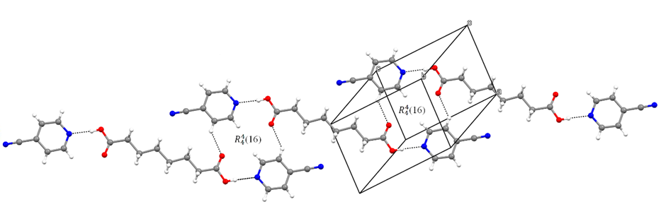
Figure S1. A portion of the crystal structure of compound 1 showing the formation of $R_{4}^{4}$(16) rings edge fused along [111].
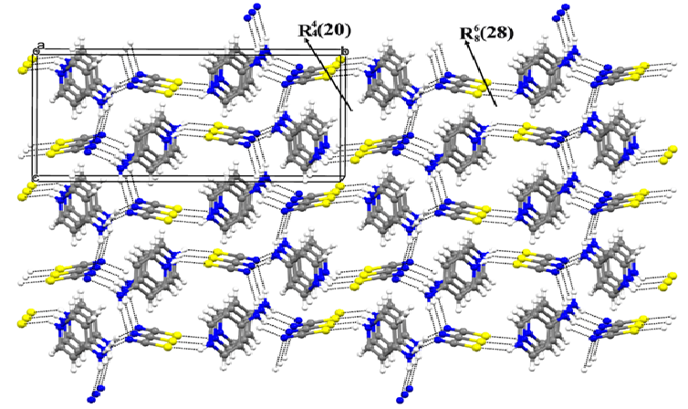
Figure S2. A portion of the crystal structure of compound 2 illustrating the formation of chain edge-fused $R_{8}^{6}$(28) and $R_{4}^{4}(20)$ rings.
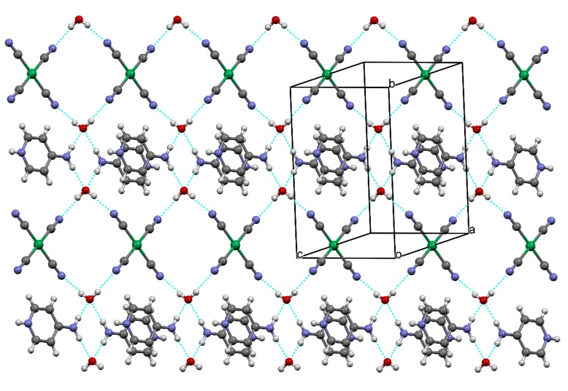
Figure S3. An infinite 3D supramolecular network.
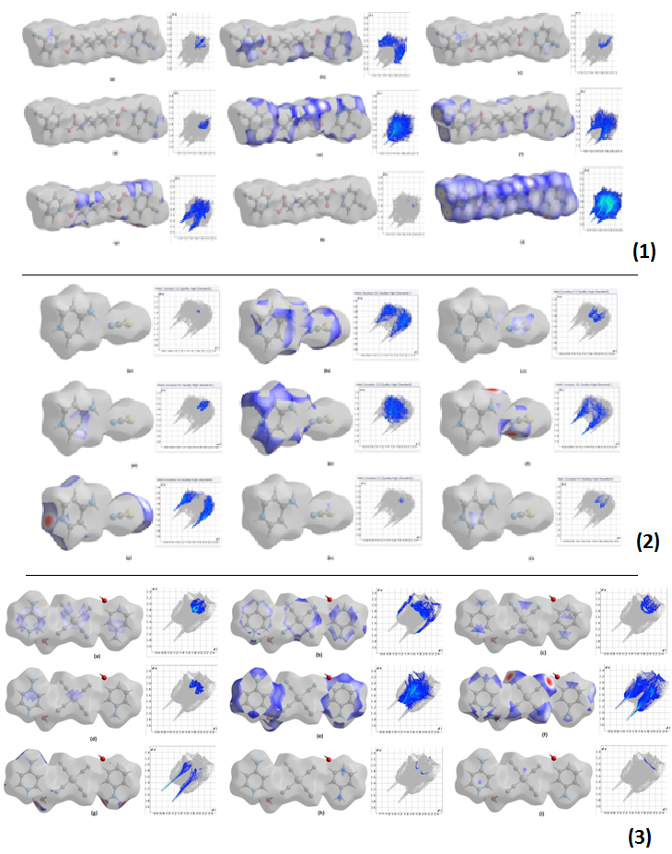
Figure S4. 2D fingerprint plots were generated to illustrate these interactions based on surface projections of compounds 1–3.
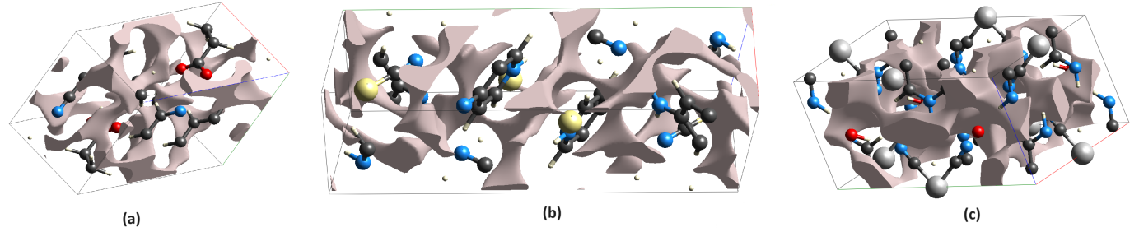
Figure S5. 3D views of the voids formed depending on the electron arrangement in the structure for (a) compound 1, (b) compound 2, and (c) compound 3.
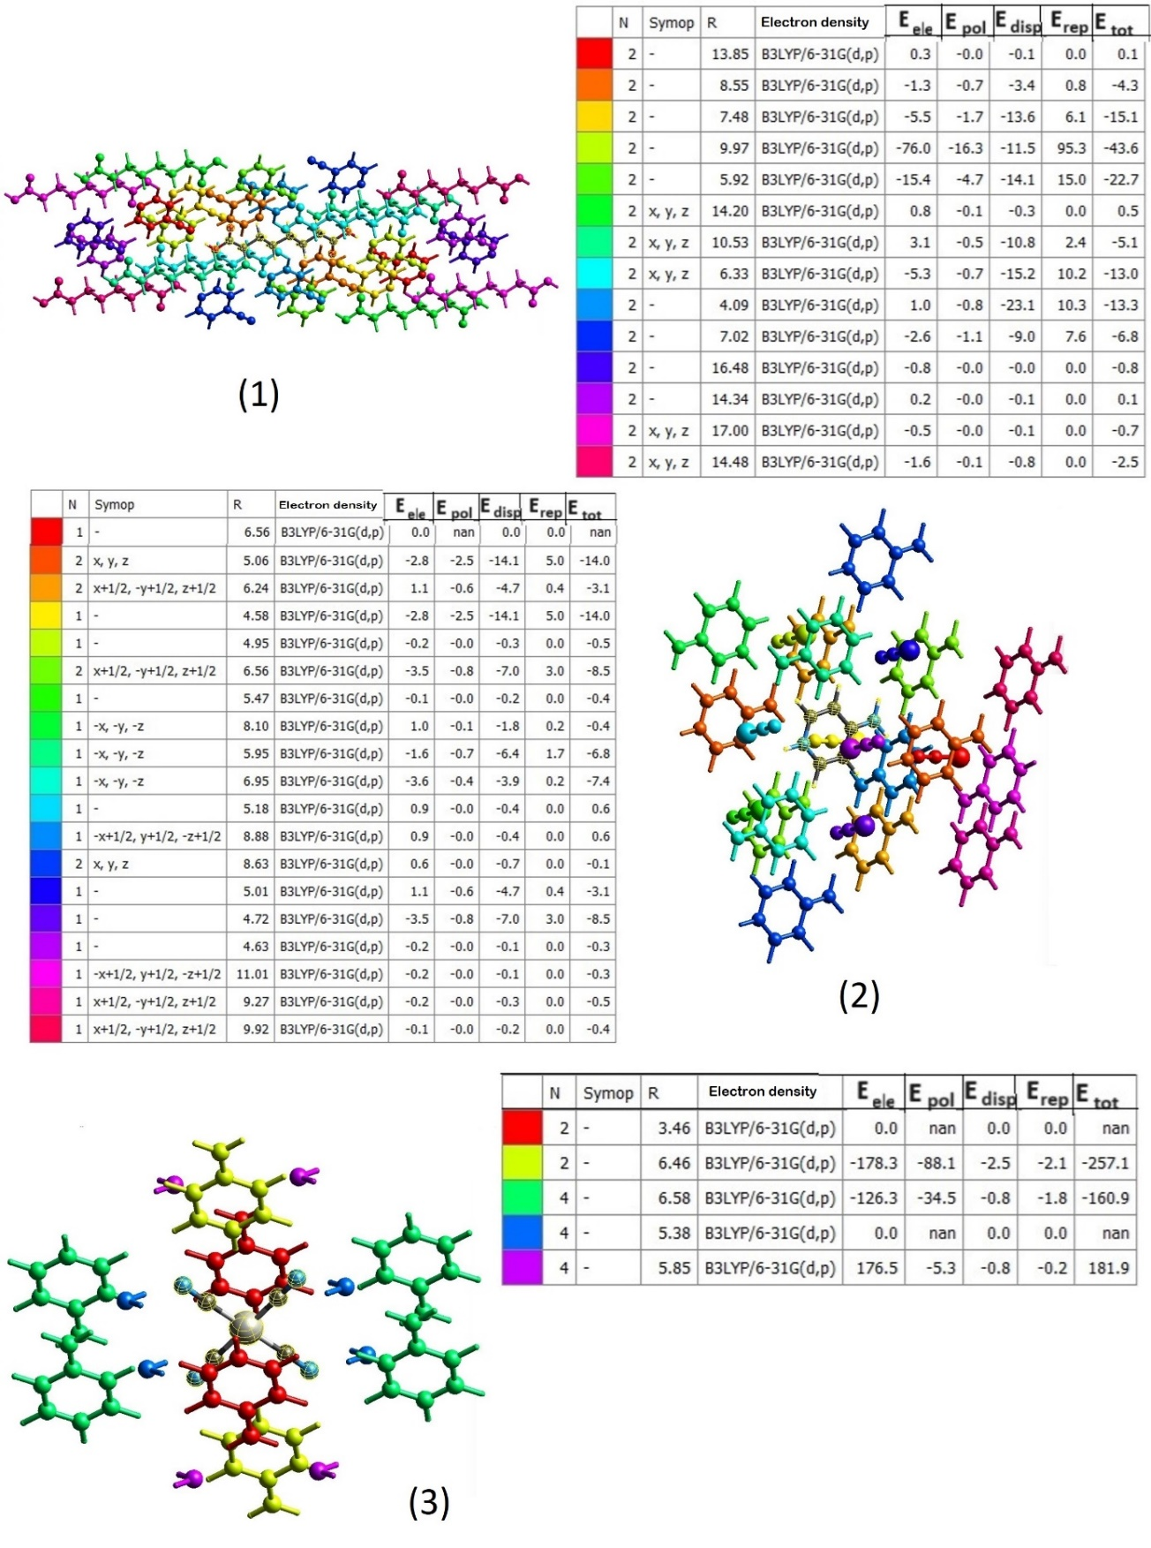
Figure S6. Energy values of the components of the total interaction energies of compounds 1–3. In the tables, N denotes the number of molecular pairs interacting with the reference molecule, Symop refers to the symmetry operations applied to the reference molecule, R indicates the distance (in Å) between the center of mass of the reference molecule and those of its neighboring molecules, and E represents the individual components of the calculated interaction energies.
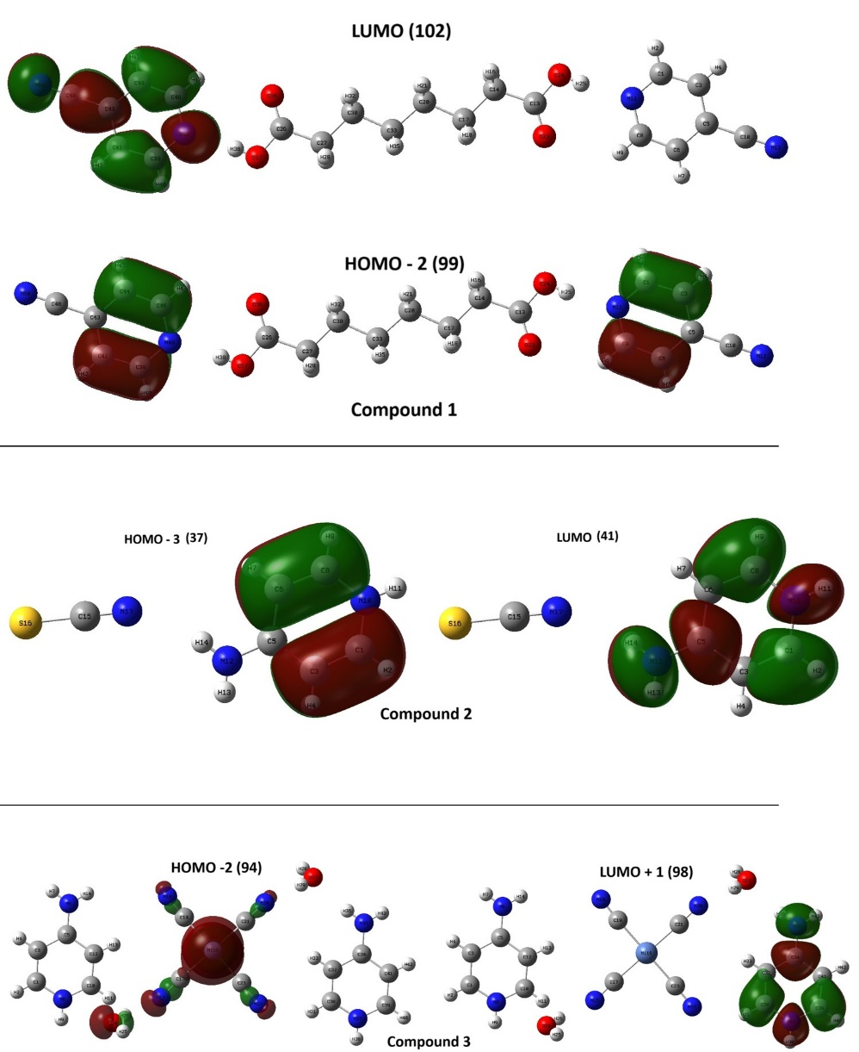
Figure S7. The charge distribution graphs of the UV transitions with the highest C_{i} coefficients of compounds 1, 2 and 3.

Table S1. Elemental analysis data for the compounds.
Compounds; M_{r} (g) | Elemental analysis, (calculated) (%)/found (%)
Compounds; M_{r} (g) | C | H | N | S | Ni
[(C₈H₁₄O₄)(C₆H₄N₂)₂];  382.41 | (62.82)  62.79 | (5.80)  5.83 | (14.65)  14.71 | (-)  - | (-)  -
[(C₅H₇N₂)⁺·(NCS)⁻];  153.20 | (47.04)  46.96 | (4.61)  4.64 | (27.43)  27.51 | (20.93)  20.98 | (-)  -
[Ni(CN)₄.2(C₅H₇N₂).2(H₂O)]; 389.04 | (43.22)  43.08 | (4.66)  4.61 | (28.80) 28.91 | (-)  - | (15.09) 15.12

Table S2. Crystallographic data of compounds 1-3.
Crystal data | 1 | 2 | 3
Empirical formula | C₂₀H₂₂N₄O₄ | C₆H₇N₃S | C₁₄H₁₈N₈O₂Ni
Formula weight | 382.41 | 153.21 | 389.07
Crystal system | Triclinic | Monoclinic | Monoclinic
Space group | P$\overline{1}$ | P2₁/n | C2/m
a (Å) | 6.3263 (6) | 5.0581 (5) | 10.4345 (13)
b (Å) | 8.5643 (8) | 17.3940 (17) | 12.6008 (16)
c (Å) | 9.5987 (10) | 8.6270 (8) | 7.3076 (10)
α (º) | 79.856 (4) | 90.000 | 90.000
β (º) | 79.921 (5) | 95.412 (3) | 108.091 (5)
γ (º) | 83.893 (4) | 90.000 | 90.000
V (Å³) | 502.50 (9) | 755.63 (13) | 913.3 (2)
Z | 1 | 4 | 2
D_{c} (g cm⁻³) | 1.264 | 1.347 | 1.415
μ (mm⁻¹) | 0.09 | 0.35 | 1.09
θ range (º) | 3.0–28.0 | 2.3–26.9 | 2.6–28.4
Measured refls. | 26630 | 20758 | 8070
Independent refls. | 2422 | 1609 | 1200
R_{int} | 0.063 | 0.028 | 0.050
S | 1.07 | 1.10 | 1.08
R1/wR2 | 0.052/0.159 | 0.033/0.076 | 0.036/0.079
T_{max}/T_{min} | 0.642/0.746 | 0.667/0.745 | 0.437, 0.746
CCDC | 2334512 | 2334585 | 2374519

Table S3. Vibration frequencies in the free states of the ligands used in the preparation of compounds and in the compounds.
Assignment | 4CP ª | SA ^{b} | 1 | 4AP ^{c} | KSCN^{d} | 2 | 4AP ^{c} | K₂Ni(CN)₄·H₂O ^{d} | 3
ν(O-H) Free H₂O | - | - | - | - | - | - | - | - | 3604 w
ν_{as}(O-H) water | - | - | - | - | - | - | - | 3469 w | -
ν_{s}(O-H) water | - | - | - | - | - | - | - | 3245 w | -
ν(O-H) carboxy. | - | 3416 w | 2668 w | - | - | - | - | - | -
ν_{as}(NH₂) | - | - | - | 3430 s | - | 3458 s | 3430 s | - | 3384 w
ν(N-H) | - | - | - | - | - | 3437 s | - | - | 3334 s
ν_{s}(NH₂) | - | - | - | 3303 w | - | 3349 s | 3303 w | - | 3235 m
ν(C-H) aromatic | 3089 w | - | 3153 w  3113 w | 3100 w | - | 3219 m | 3100 w | - | 3160 m
ν(C-H) aromatic | 3023 w | - | 3088 m  3041 w | 3079 w | - | 3068 w | 3079 w | - | 3053 m
ν(C-H) aliphatic | - | 2943 s | 2943 s | - | - | - | - | - | -
ν(COH) | - | 2869 m | 2866 w | - | - | - | - | - | -
δ(O-H) carboxylic | - | 2530 w | 2765 w | - | - | - | - | - | -
ν(C≡N) | 2235 m | - | 2240 m | - | 2036 s | 2104 s  2071 s  2023 w | - | 2121 s | 2123 s
ν(C=O) carboxy. | - | 1683 s | 1709 s | - | - | - | - | - | -
δ(OH) water | - | - | - | - | - | - | - | 1652 s | 1650 s
δ(NH₂) | - | - | - | 1649 m | - | 1685 w | 1649 m | - | 1673 s
ν(C=C) | 1588 m | - | 1600 s | 1585 s | - | 1624 s | 1585 s | - | 1650 s
ν(C-C) | 1541 m |  | 1547 m | 1429 w | - | 1449 m | 1429 w | - | 1402 m
ν(C-N) | 1486 m | - | 1499 m | 1267 m | - | 1280 m | 1267 m | - | 1241 w
δ(CH₂) | - | 1466 w | 1465 w | - | - | - | - | - | -
ν(C-N) | 1413 m | - | 1410 s | - | - | - | - | - | -
δ(C=O) carboxy., δ(HCH) | - | 1332 s  1254 s  1190 s | 1332 s  1240 s  1179 s | - | - | - | - | - | -
ν_{ring} (2.) | 1079 m | - | 1071w | - | - | - |  | - | -
ω(CH₂), δ(C-O) | - | 1059w | 1064 s | - | - | - | - | - | -
ν_{ring} (1.) | 982 m | - | 1007 s | 976 s | - | 1013 s | 976 s | - | 997 s
ν(C-S) | - | - | - | - | 740 m | 824 s | - | - | -
ν(Ni-CN) | - | - | - | - | - | - | - | 544 w | 530 w
δ(NCS) | - | - | - | - | 474 s | 529 s | - | - | -
π(Ni-CN) | - | - | - | - | - | - | - | 442 w | 496 s
δ(Ni-CN) | - | - | - | - | - | - | - | 420 w | 414 s
ν: stretching; δ: in plane bending; π: out of plane bending; ω: wagging; s: strong; m: medium; w: weak; ª taken from Macrae et al. [36], ^{b} taken from Kartal and Şahin [21].

Table S4. Mulliken electric charges of the atoms in compounds 1–3 and their values ​​in terms of free electron charge (e).
Compound 1
Atom | ACVFL | ACVC | Atom | ACVFL | ACVC | Atom | ACVFL | ACVC
C1 | 0.185957 | 0.099877 | H9A | 0.142383 | 0.171837 | H10B | 0.141712 | 0.159087
H1 | 0.023729 | 0.198678 | H9B | 0.15869 | 0.191049 | O1^{i} | -0.30536 | -0.42514
C2 | -0.1224 | -0.16006 | C10 | -0.23221 | -0.33283 | O2^{i} | -0.21499 | -0.56903
H2 | 0.060696 | 0.203404 | H10A | 0.140167 | 0.160398 | H2A^{i} | 0.26926 | 0.41346
C3 | 0.212041 | 0.125705 | H10B | 0.135592 | 0.173881 | C5^{i} | 0.18596 | 0.09995
C4 | -0.12165 | -0.1438 | O1 | -0.25318 | -0.42502 | H5^{i} | 0.023729 | 0.19919
H4 | 0.074322 | 0.206395 | O2 | -0.1496 | -0.56927 | C4^{i} | -0.1224 | -0.15988
C5 | 0.192347 | 0.079094 | H2A | 0.240284 | 0.413334 | H4^{i} | 0.060696 | 0.203937
H5 | 0.038906 | 0.248688 | C7 | 0.036922 | 0.521698 | C3^{i} | 0.212041 | 0.125701
C6 | 0.136608 | -0.21773 | C8 | -0.14066 | -0.46139 | C6^{i} | -0.12165 | -0.14398
N1 | -0.36829 | -0.5239 | H8A | 0.187923 | 0.207189 | H2^{i} | 0.074322 | 0.20588
N2 | -0.31227 | -0.0685 | H8B | 0.169527 | 0.21938 | C2^{i} | 0.192347 | 0.07899
C7 | -0.46826 | 0.521449 | C9 | -0.35082 | -0.31916 | H1^{i} | 0.038906 | 0.248284
C8 | -0.32338 | -0.46108 | H9A | 0.154158 | 0.186726 | C1^{i} | 0.136608 | -0.21773
H8A | 0.183773 | 0.221749 | H9B | 0.164792 | 0.178489 | N1^{i} | -0.36829 | -0.52395
H8B | 0.160461 | 0.206576 | C10 | -0.27269 | -0.33276 | N2^{i} | -0.31227 | -0.06852
C9 | -0.04779 | -0.31918 | H10A | 0.14608 | 0.172796
Symmetry code: (i) -x, 2-y, 2-z
Compound 2
Atom | ACVFL | ACVC | Atom | ACVFL | ACVC | Atom | ACVFL | ACVC
C1 | -0.339235 | 0.182705 | H4 | 0.107513 | 0.267343 | H2A | 0.233609 | 0.356867
H1 | 0.129635 | 0.240808 | C5 | -0.339235 | 0.190058 | H2B | 0.233609 | 0.387064
C2 | 0.253458 | -0.29816 | H5 | 0.129635 | 0.247489 | C6 | 0.096503 | -0.23122
H2 | 0.107513 | 0.237178 | N1 | -0.112994 | -0.67646 | S1 | 0.107499 | -0.23649
C3 | -0.293325 | 0.422293 | H1A | - | 0.358431 | N3 | -0.204003 | -0.39235
C4 | 0.253458 | -0.25616 | N2 | -0.363642 | -0.7994
Compound 3
Atom | ACVFL | ACVC | Atom | ACVFL | ACVC | Atom | ACVFL | ACVC
C1 | 0,310923 | 0,267627 | Ni1 | 2,183421 | -0,090983 | H1^{ii} | 0.015475 | 0.180884
H1 | 0,015475 | 0,107014 | C4 | -0,707764 | 0,300629 | C2^{ii} | -0.254572 | -0.291715
C2 | -0,254572 | -0,2859 | N3^{iv} | -0,337463 | -0,591525 | H2^{ii} | 0.029941 | 0.134226
H2 | 0,029941 | 0,083524 | C4^{iv} | -0,708138 | 0,116542 | C3^{ii} | 0.657298 | 0.82504
C3 | 0,657298 | 0,823835 | N3^{v} | -0,337221 | -0,67594 | N2^{ii} | -0.704055 | -0.769413
N2 | -0,704055 | -0,734464 | C4^{v} | -0,709188 | 0,212215 | H3^{ii} | 0.199996 | 0.356279
H3A | 0,199996 | 0,255071 | N3^{iii} | -0,337316 | -0,702929 | N1^{ii} | -0.556768 | -0.442579
N1 | -0,556768 | -0,414606 | C4^{iii} | -0,708784 | 0,204251 | H1A^{ii} | 0 | 0.273931
H1A | 0 | 0,28208 | O1 | -0,714341 | -0,726339 | C1^{iii} | 0.310923 | 0.268312
C1^{i} | 0,310923 | 0,336997 | H4 | 0,357171 | 0,317839 | H1^{iii} | 0.015475 | 0.103998
H1^{i} | 0,015475 | 0,182776 | H4^{i} | 0,357171 | 0,395203 | C2^{iii} | -0.254572 | -0.29349
C2^{i} | -0,254572 | -0,288087 | O1^{v} | -0.714341 | -0.766539 | H2^{iii} | 0.029941 | 0.082008
H2^{i} | 0,029941 | 0,135542 | H4^{v} | 0.357171 | 0.320312 | H3^{iii} | 0.199996 | 0.252242
H3^{i} | 0,199996 | 0,28019 | H4^{ii} | 0.357171 | 0.320312
N3 | -0,337546 | -0,795252 | C1^{ii} | 0.310923 | 0.341625
Symmetry codes: (i) x, −y+1, z; (ii) x, y+1, z; (iii) x, −y+2, z; (iv) 1−x, y, −z+2; (v) 1−x, −y+2, −z+2
ACVFL: atomic charge value in free ligand, ACVC: atomic charge value in the compound.
Table S5. General properties of voids in unit cells of compounds 1–3.
Compounds | Volume (Å³) | RVVTV (%) | Void area (Å²) | Globularity | Asphericity
1 | 51.57 | 10.26 | 209.23 | 0.320 | 0.071
2 | 62.01 | 08.21 | 283.34 | 0.267 | 0.363
3 | 101.62 | 11.13 | 399.12 | 0.264 | 0.094
RVVTV (%): ratio of void volume to total volume (%).
Table S6. Theoretically calculated absorption wavelength (λ), excitation energy values, ​​​​and oscillator strengths (f) for electronic transitions in the UV–visible region of compounds 1–3 in water.
Compounds | Exc. States | Exc. energy (eV) | W. length (nm) | Osc. strengths | Assignments |  | Coefficients  C_{i}
 |  |  |  |  | From → to |  | Coefficients  C_{i}
1 | 1 | 4.5752 | 270.99 | 0.0022 | 101 →102 |  | 0.35297
1 | 2 | 5.0403 | 245.99 | 0.0537 | 99 →102 |  | 0.42547
2 | 1 | 5.2943 | 234.18 | 0.0311 | 40 → 43 | 0.60991
2 | 2 | 5.2998 | 233.94 | 0.0365 | 39 → 43 | 0.60626
2 | 3 | 5.3711 | 230.83 | 0.3522 | 38 → 41 | 0.60937
2 | 4 | 5.9019 | 210.07 | 0.0065 | 40 → 48 | 0.30511
2 | 5 | 5.9284 | 209.14 | 0.0153 | 39 → 44 | 0.44050
2 | 6 | 5.9374 | 208.82 | 0.0094 | 40 → 44 | 0.36001
2 | 7 | 6.2667 | 197.84 | 0.2529 | 37 → 41 | 0.61766
2 | 8 | 6.3377 | 195.63 | 0.0783 | 39 → 45 | 0.44512
2 | 9 | 6.3555 | 195.08 | 0.0099 | 40 → 46 | 0.43463
2 | 10 | 6.4032 | 193.63 | 0.1327 | 39 → 46 | 0.40721
2 | 11 | 6.6465 | 186.54 | 0.1281 | 39 → 48 | 0.33577
3 | 1 | 3.8337 | 323.40 | 0.0046 | 96 →100 | 0.63710
3 | 2 | 4.4894 | 276.17 | 0.0018 | 95 →100 | 0.53491
3 | 3 | 4.5040 | 275.28 | 0.0010 | 95 →101 | 0.61746
3 | 4 | 4.5855 | 270.38 | 0.0010 | 94 → 98 | 0.69440
3 | 5 | 4.6296 | 267.81 | 0.0010 | 91 → 97 | 0.62552

Table S7. The NMR theoretical isotropic and anisotropic chemical and magnetic shielding values calculated for compounds 1–3 in water at room temperature.
Atoms | Degeneracy | Chemical and Magnetic shielding values (ppm) |  |  | Atoms |  | Degeneracy |  | Chemical and Magnetic shielding values (ppm)
Atoms | Degeneracy | Isotropic |  | Anisotropic |  |  |  |  | Isotropic |  |  | Anisotropic
Atoms | Degeneracy | Average | Shielding value corrected to TMS | Anisotropic |  |  |  |  | Average | Shielding value corrected to TMS
Compound 1 |  |  |  |  |  | Compound 3
N1; N1^{i} | 2 | -77.4686 | - | 582.0642; 582.0335 | Ni1 |  | 1 |  | -2586.7388 | - |  | 1827.9694
O1^{i}; O1 | 2 | -55.5268 | - | 548.0302; 547.9990 | N3^{iv} |  | 1 |  | 18.4187 | - |  | 404.4922
N2^{i}; N2 | 2 | -20.9669 | - | 404.8143; 404.8767 | N3^{iii} |  | 1 |  | 19.0846 | - |  | 404.1132
C7^{i}; C7 | 2 | 2.5300 | 179.9356 | 110.6551; 110.6303 | H1A; H1; H1^{i} |  | 3 |  | 27.0021 | 4.8800 |  | 10.5859; 3.8035; 3.7475
H1^{i}; H5 | 2 | 24.8471 | 7.0350 | 12.6492; 12.6487 | H1^{ii}; H2 |  | 2 |  | 27.0939 | 4.7882 |  | 4.5607; 5.3910
40; 2 | 2 | 25.0739 | 6.8082 | 10.9427; 10.9453 | H1A^{ii} |  | 1 |  | 27.1650 | 4.7171 |  | 11.3373
H2^{i}; H4 | 2 | 26.4604 | 5.4218 | 10.4524; 10.4497 | N3^{v} |  | 1 |  | 27.2534 | - |  | 394.4694
H4i; H2; H2A^{i}; H2A | 4 | 26.5820 | 5.3001 | 9.6859; 9.6866; 25.7544; 25.7555 | N3 |  | 1 |  | 27.3236 | - |  | 394.5214
C1; C5^{i} | 2 | 31.8678 | 150.5979 | 205.1792; 205.1587 | H2^{i}; C2^{ii} |  | 2 |  | 27.8204 | 4.0617 |  | 5.6677; 5.4956
C2^{i}; C5 | 2 | 32.7743 | 149.6913 | 208.3641; 208.3544 | H2 |  | 1 |  | 28.0483 | 3.8338 |  | 5.3910
H8A^{i}; H8A | 2 | 33.5398 | -1.6577 | 6.4264; 6.4265 | H2^{iii} |  | 1 |  | 28.1013 | 3.7808 |  | 5.7788
H8B^{i}; H8B | 2 | 33.6326 | -1.7505 | 6.8397; 6.8402 | H3^{ii} |  | 1 |  | 29.9086 | 1.9735 |  | 23.0404
H9A^{i}; H9A; H9B^{i}; H9B | 4 | 34.7525 | -2.8704 | 6.5594; 6.5588; 6.4658; 6.4662 | H3^{iii} |  | 1 |  | 30.8971 | 0.9850 |  | 16.0191
H10B^{i}; H10B; H10A^{i}; H10A | 4 | 35.0636 | -3.1815 | 5.6887; 5.6887; 5.8884; 5.8883 | H3 |  | 1 |  | 30.9689 | 0.9132 |  | 17.3244
C6^{i}; C4; C4^{i}; C2 | 4 | 57.0092 | 125.4565 | 205.0740; 205.0513; 204.6876; 204.6891 | H3^{i} |  | 1 |  | 31.0493 | 0.8328 |  | 16.3431
C3^{i}; C3 | 2 | 57.8151 | 124.6505 | 166.5969; 166.5523 | H4^{ii} |  | 1 |  | 39.8542 | -7.9721 |  | 33.1446
C6; C1^{i} | 2 | 59.9681 | 122.4975 | 343.5704; 343.5635 | H4^{i} |  | 1 |  | 40.5973 | -8.7152 |  | 32.6554
O2^{i}; O2 | 2 | 136.5687 | - | 150.3062; 150.3564 | H4^{v} |  | 1 |  | 40.7827 | -8.9006 |  | 27.4667
C8^{i}; C8 | 2 | 163.2417 | 19.2239 | 60.3515; 60.3550 | H4 |  | 1 |  | 41.6419 | -9.7598 |  | 27.7890
C10^{i}; C10 | 2 | 174.4890 | 7.9767 | 40.3303; 40.3291 | C3^{ii}; C3 |  | 2 |  | 111.2826 | 71.1830 |  | 145.0106; 144.8900
C9^{i}; C9 | 2 | 177.9147 | 4.5510 | 34.1464; 34.1461 | C1^{i} |  | 1 |  | 123.3134 | 59.1522 |  | 132.0055
Compound 2 |  |  |  |  |  | C1^{ii} |  | 1 | 123.5421 |  | 58.9235 |  | 130.9552
C3 | 1 | 20.1622 | 162.3034 | 212.9816 | C1 |  | 1 |  | 123.6703 | 58.7953 |  | 131.0293
H1A | 1 | 26.2784 | 5.6037 | 5.2996 | C1^{iii} |  | 1 |  | 124.0354 | 58.4302 |  | 130.5657
H1 | 1 | 26.4928 | 5.3893 | 6.7229 | C2^{iii} |  | 1 |  | 140.5114 | 41.9542 |  | 130.1068
H5 | 1 | 26.5561 | 5.3260 | 6.9611 | C2 |  | 1 |  | 140.5915 | 41.8741 |  | 130.8112
H2 | 1 | 27.6679 | 4.2142 | 8.1085 | C2^{i} |  | 1 |  | 141.1750 | 41.2906 |  | 129.6856
H3 | 1 | 27.8076 | 4.0745 | 8.4217 | C2^{ii} |  | 1 |  | 141.4054 | 41.0602 |  | 128.8266
H2B | 1 | 31.5921 | 0.2900 | 19.5286 | C4 |  | 1 |  | 157.2165 | 25.2491 |  | 195.3953
H2A | 1 | 32.5481 | -0.6660 | 8.8607 | C4^{v} |  | 1 |  | 157.8921 | 24.5735 |  | 194.5823
N3 | 1 | 40.9136 | - | 461.3638 | C4^{iii} |  | 1 |  | 160.6767 | 21.7889 |  | 190.2298
C1 | 1 | 44.8297 | 137.6359 | 188.5759 | C4^{iv} |  | 1 |  | 161.6263 | 20.8393 |  | 188.7025
C5 | 1 | 46.2372 | 136.2284 | 187.5499 | N1 |  | 1 |  | 207.9435 | - |  | 142.1206
C6 | 1 | 46.6949 | 135.7707 | 367.2538 | N1^{ii} |  | 1 |  | 208.9679 | - |  | 140.1005
C2 | 1 | 75.5923 | 106.8733 | 164.1584 | N2^{ii} |  | 1 |  | 253.0385 | - |  | 40.2423
C3 | 1 | 76.1971 | 106.2685 | 164.6129 | N2 |  | 1 |  | 255.5806 | - |  | 35.4744
N1 | 1 | 101.1524 | - | 227.4076 | O1 |  | 1 |  | 431.0153 | - |  | 19.1125
N2 | 1 | 179.3116 | - | 65.2685 | O1^{v} |  | 1 |  | 433.2705 | - |  | 19.5665
S1 | 1 | 800.4815 | - | 393.7182

