SUPPORTING INFORMATIONS
Supplementary Figures

Figure S1. RMSD of the carbon backbone atoms of the RNA-dependent RNA polymerase (RdRp) protein with the top three compound complexes with nucleophilic addition to a bond reaction over 100 ns molecular dynamics (MD) simulations.

Figure S2. RMSD of the carbon backbone atoms of the RNA-dependent RNA polymerase (RdRp) protein with the top three compound complexes with nucleophilic substitution reaction over 100 ns molecular dynamics (MD) simulations.

Figure S3. RMSD of the carbon backbone atoms of the RNA-dependent RNA polymerase (RdRp) protein with the top three compound complexes with michael addition reaction over 100 ns molecular dynamics (MD) simulations.

Figure S4. RMSD of the carbon backbone atoms of the transmembrane serine protease 2 (TMPRSS2) protein with the top three compound complexes with nucleophilic addition reaction over 100 ns molecular dynamics (MD) simulations.

Figure S5. RMSD of the carbon backbone atoms of the main protease (Mpro2) protein with the top three compound complexes with betalactam reaction over 100 ns molecular dynamics (MD) simulations.

Figure S6. RMSD of the carbon backbone atoms of the main protease (Mpro2) protein with the top three compound complexes with nuctriple reaction over 100 ns molecular dynamics (MD) simulations.

Figure S7. RMSD of the carbon backbone atoms of angiotensin-converting enzyme 2 (Ace2) protein with the top three compound complexes with betalactam reaction over 100 ns molecular dynamics (MD) simulations.

Figure S8. RMSD of the carbon backbone atoms of angiotensin-converting enzyme 2 (Ace2) protein with the top three compound complexes with epoxy reaction over 100 ns molecular dynamics (MD) simulations.

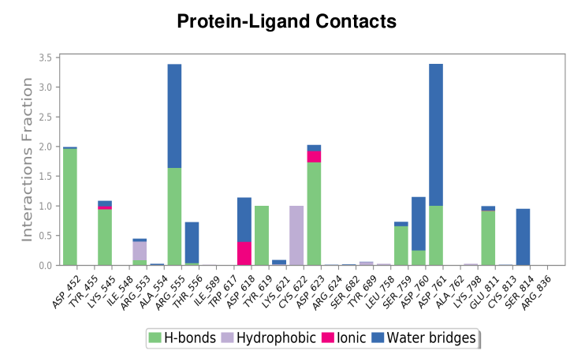
Figure S9. The bar chart illustrates the nucleophilic addition to double bond reaction formed between the drug bremelanotidedat and the RdRP protein, highlighting hydrogen bonds, hydrophobic interactions, ionic bonds, and water bridges during 100 ns molecular simulations.

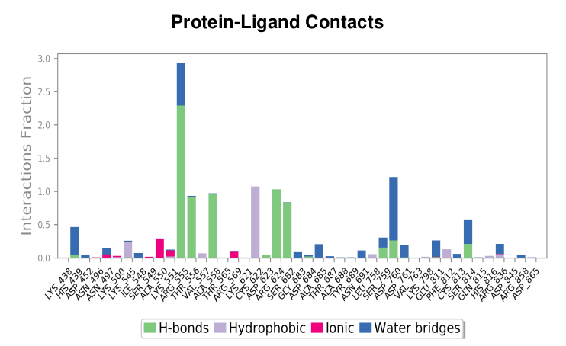
Figure S10. The bar chart illustrates the nucleophilic addition to double bond reaction formed between the drug lanreotide and the RdRP protein, highlighting hydrogen bonds, hydrophobic interactions, ionic bonds, and water bridges during 100 ns molecular simulations.
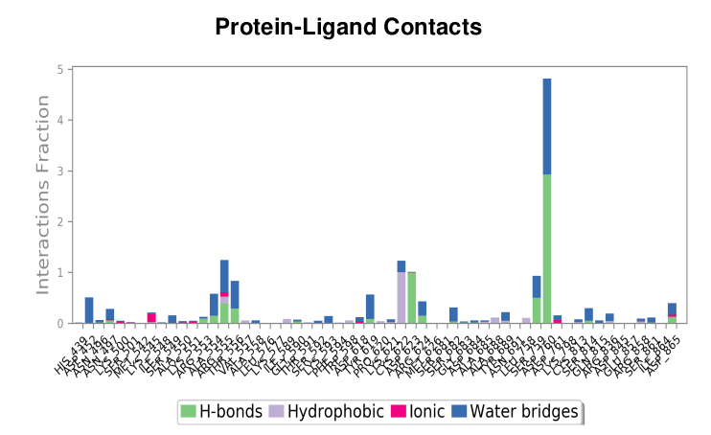
Figure S11. The bar chart illustrates the nucleophilic addition to double bond reaction formed between the drug histrelin and the RdRP protein, highlighting hydrogen bonds, hydrophobic interactions, ionic bonds, and water bridges during 100 ns molecular simulations.

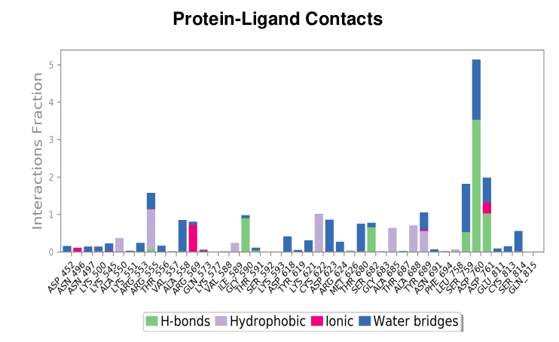
Figure S12. The bar chart illustrates the nucleophilic addition to double bond reaction formed between the drug leuprolide and the RdRP protein, highlighting hydrogen bonds, hydrophobic interactions, ionic bonds, and water bridges during 100 ns molecular simulations.
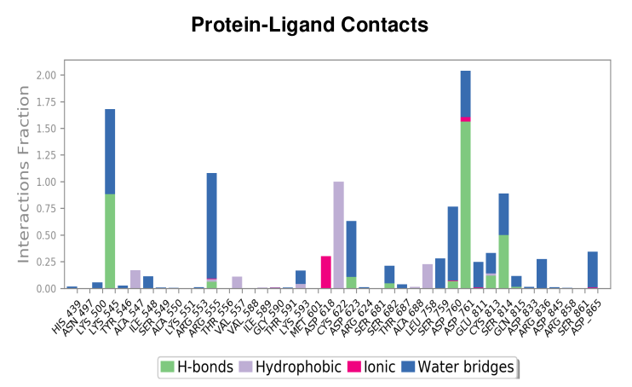
Figure S13. The bar chart illustrates the nucleophilic substitution reaction formed between the drug tenapanor and the RdRP protein, highlighting hydrogen bonds, hydrophobic interactions, ionic bonds, and water bridges during 100 ns molecular simulations.

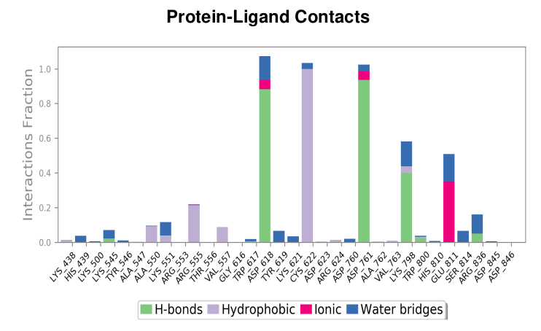
Figure S14. The bar chart illustrates the nucleophilic substitution reaction formed between the drug isavuconazonium and the RdRP protein, highlighting hydrogen bonds, hydrophobic interactions, ionic bonds, and water bridges during 100 ns molecular simulations.
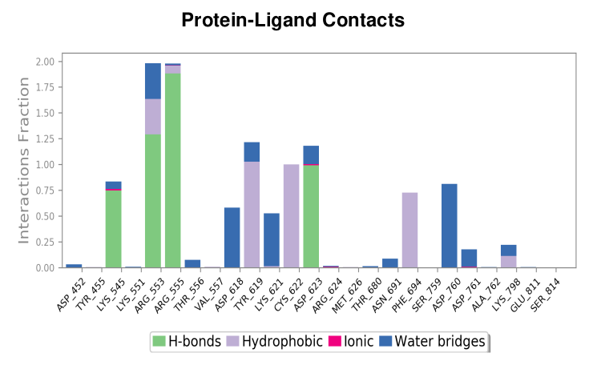
Figure S15. The bar chart illustrates the nucleophilic substitution reaction formed between the drug elagolix and the RdRP protein, highlighting hydrogen bonds, hydrophobic interactions, ionic bonds, and water bridges during 100 ns molecular simulations.

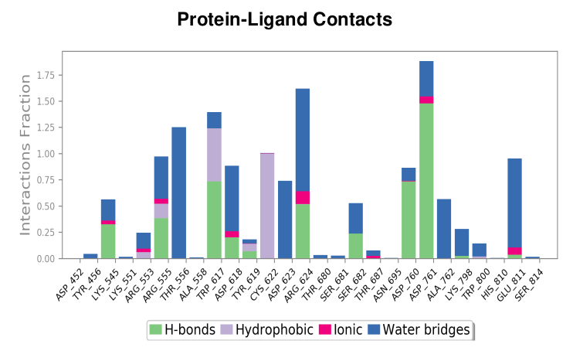
Figure S16. The bar chart illustrates the nucleophilic substitution reaction formed between the drug alatrofloxacin and the RdRP protein, highlighting hydrogen bonds, hydrophobic interactions, ionic bonds, and water bridges during 100 ns molecular simulations.
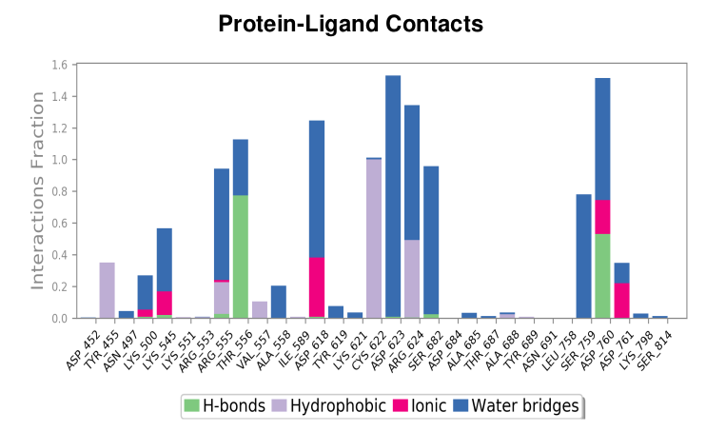
Figure S17. The bar chart illustrates the nucleophilic substitution reaction formed between the drug valrubicin and the RdRP protein, highlighting hydrogen bonds, hydrophobic interactions, ionic bonds, and water bridges during 100 ns molecular simulations.

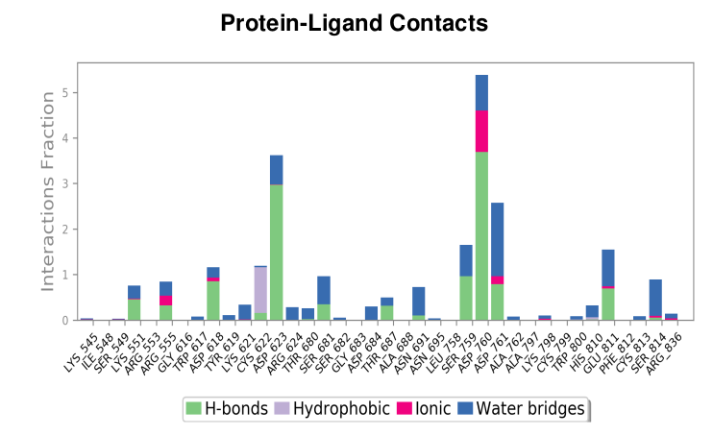
Figure S18. The bar chart illustrates the michael addition reaction formed between the drug capreomycin and the RdRP protein, highlighting hydrogen bonds, hydrophobic interactions, ionic bonds, and water bridges during 100 ns molecular simulations.

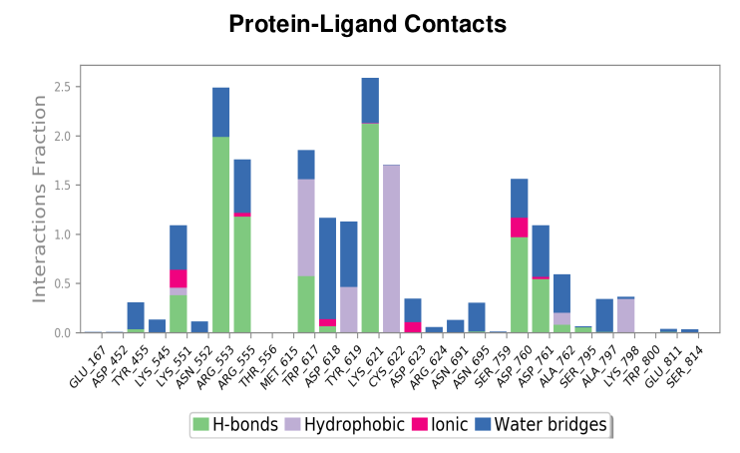
Figure 19. The bar chart illustrates the michael addition reaction formed between the drug ceftolozane and the RdRP protein, highlighting hydrogen bonds, hydrophobic interactions, ionic bonds, and water bridges during 100 ns molecular simulations.

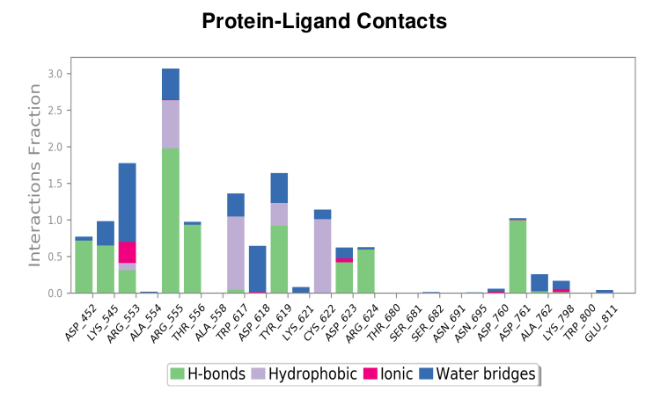
Figure S20. The bar chart illustrates the michael addition reaction formed between the drug ceftobiprole and the RdRP protein, highlighting hydrogen bonds, hydrophobic interactions, ionic bonds, and water bridges during 100 ns molecular simulations.

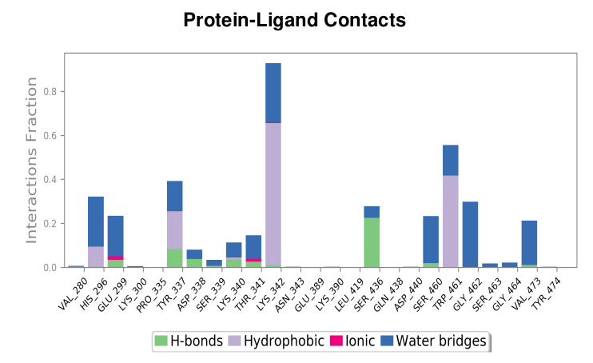
Figure S21. The bar chart illustrates the nuclephilic addition reaction formed between the drug isavuconazonium and the TMPRSS2 protein, highlighting hydrogen bonds, hydrophobic interactions, ionic bonds, and water bridges during 100 ns molecular simulations.

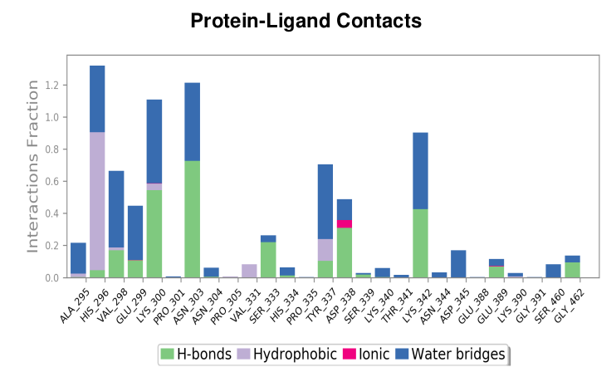
Figure S22. The bar chart illustrates the nuclephilic addition reaction formed between the drug tenapanor and the TMPRSS2 protein, highlighting hydrogen bonds, hydrophobic interactions, ionic bonds, and water bridges during 100 ns molecular simulations.
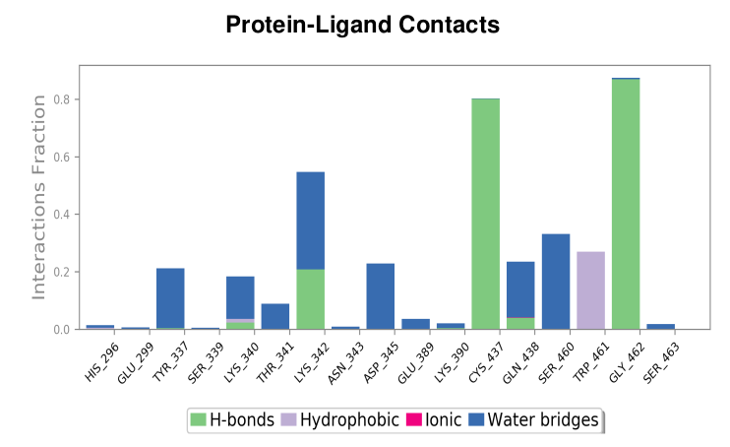
Figure S23. The bar chart illustrates the nuclephilic addition reaction formed between the drug ivosidenib and the TMPRSS2 protein, highlighting hydrogen bonds, hydrophobic interactions, ionic bonds, and water bridges during 100 ns molecular simulations.

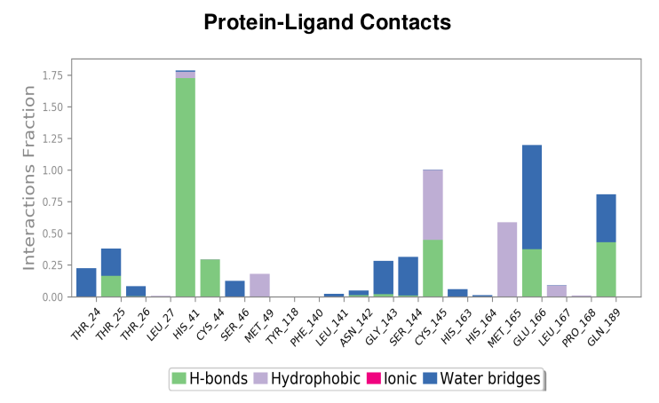
Figure S24. The bar chart illustrates the betalactam reaction formed between the drug azlocillin and the Mpro protein, highlighting hydrogen bonds, hydrophobic interactions, ionic bonds, and water bridges during 100 ns molecular simulations.

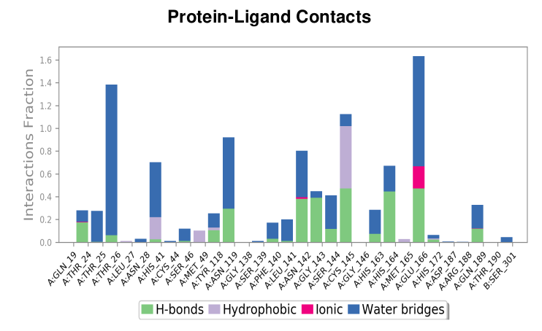Figure S25. The bar chart illustrates the betalactam reaction formed between the drug cefiderecol and the Mpro protein, highlighting hydrogen bonds, hydrophobic interactions, ionic bonds, and ater bridges during 100 ns molecular simulations.

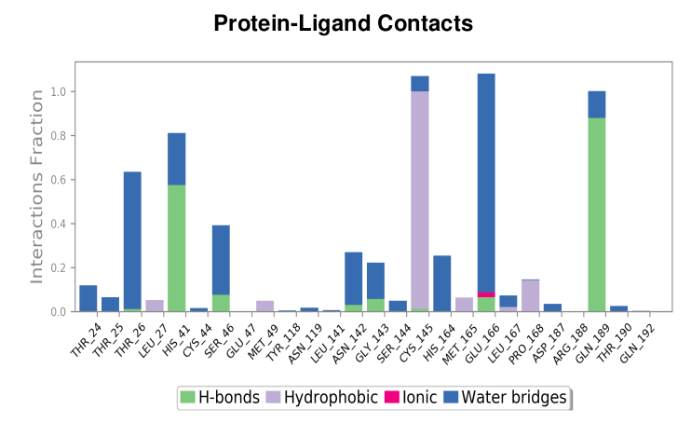
Figure S26. The bar chart illustrates the betalactam reaction formed between the drug sultamicillin and the Mpro protein, highlighting hydrogen bonds, hydrophobic interactions, ionic bonds, and water bridges during 100 ns molecular simulations.

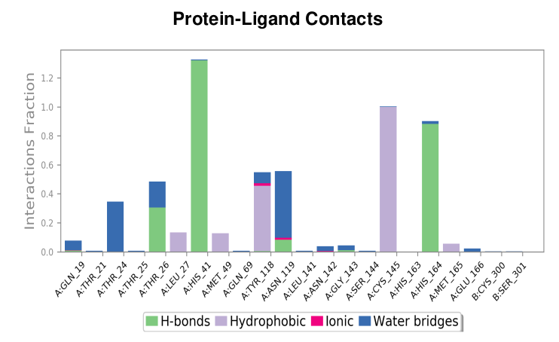Figure S27. The bar chart illustrates the nuctriple reaction formed between the drug ozanimod and the Mpro protein, highlighting hydrogen bonds, hydrophobic interactions, ionic bonds, and water bridges during 100 ns molecular simulations.

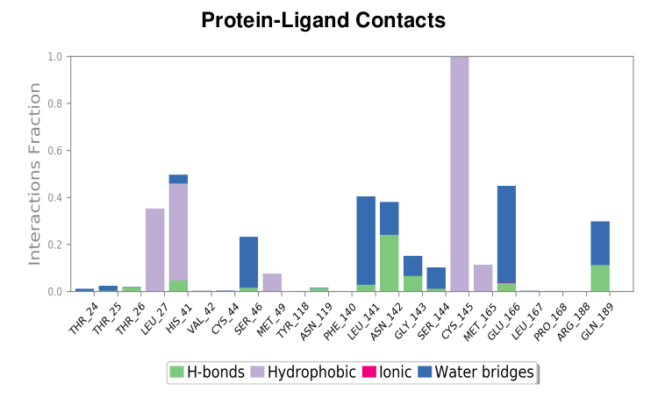Figure S28. The bar chart illustrates the nuctriple reaction formed between the drug darolutamide and the Mpro protein, highlighting hydrogen bonds, hydrophobic interactions, ionic bonds, and water bridges during 100 ns molecular simulations.
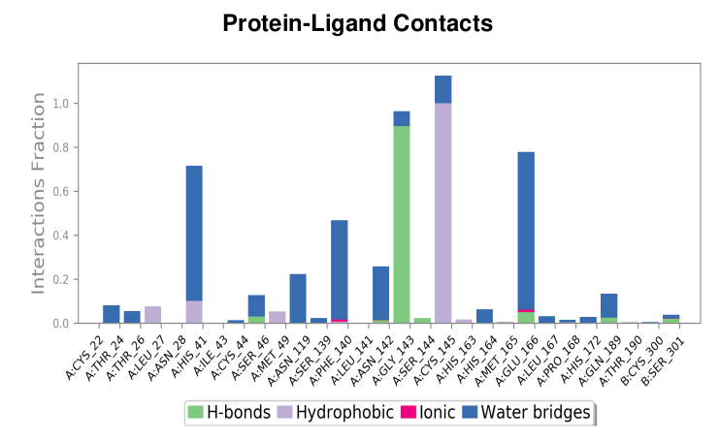
Figure S29. The bar chart illustrates the nuctriple reaction formed between the drug selpercatinib and the Mpro protein, highlighting hydrogen bonds, hydrophobic interactions, ionic bonds, and water bridges during 100 ns molecular simulations.

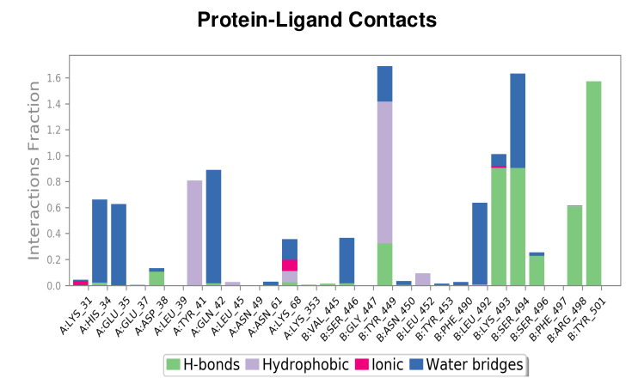
Figure S30. The bar chart illustrates the betalactam reaction formed between the drug cefiderocol and the Ace2 protein, highlighting hydrogen bonds, hydrophobic interactions, ionic bonds, and water bridges during 100 ns molecular simulations.

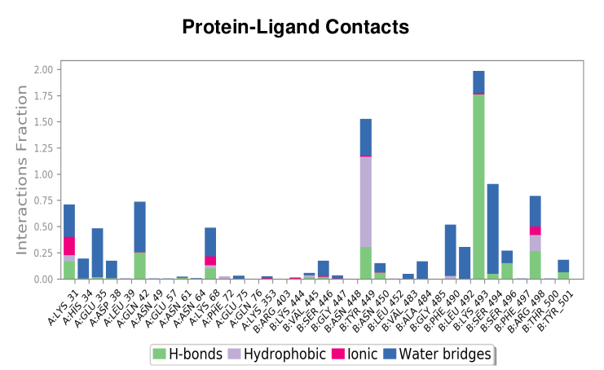
Figure S31. The bar chart illustrates the betalactam reaction formed between the drug ceftolozane and the Ace2 protein, highlighting hydrogen bonds, hydrophobic interactions, ionic bonds, and water bridges during 100 ns molecular simulations.

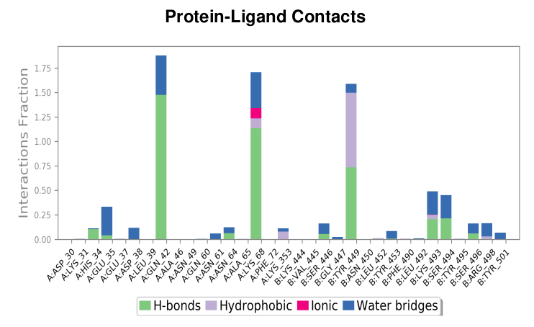
Figure S32. The bar chart illustrates the betalactam reaction formed between the drug cefoperazone and the Ace2 protein, highlighting hydrogen bonds, hydrophobic interactions, ionic bonds, and water bridges during 100 ns molecular simulations.
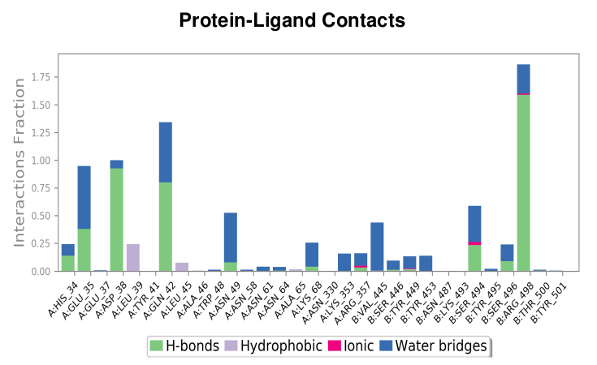
Figure S33. The bar chart illustrates the epoxy reaction formed between the drug mupirocin and the Ace2 protein, highlighting hydrogen bonds, hydrophobic interactions, ionic bonds, and water bridges during 100 ns molecular simulations.

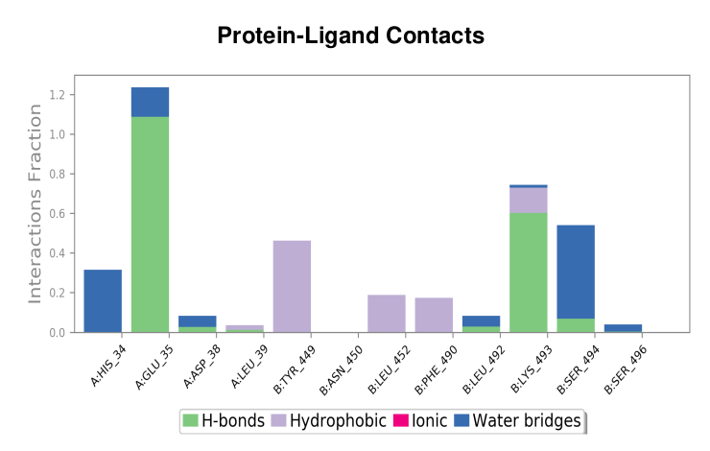
Figure S34. The bar chart illustrates the epoxy reaction formed between the drug methscopolamine bromide and the Ace2 protein, highlighting hydrogen bonds, hydrophobic interactions, ionic bonds, and water bridges during 100 ns molecular simulations.
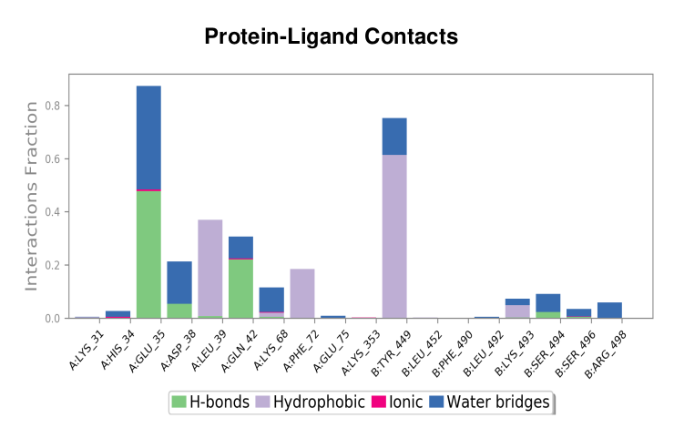
Figure S35. The bar chart illustrates the epoxy reaction formed between the drug methscopolamine and the Ace2 protein, highlighting hydrogen bonds, hydrophobic interactions, ionic bonds, and water bridges during 100 ns molecular simulations.
,

Identification of Potential Inhibitors Targeting SARS-CoV-2 RNA-Dependent RNA Polymerase through Covalent Docking Study with Nucleophilic Substitution Reaction.
Table1: MM-GBSA scores and interaction residues for nucleophilic substitution reaction’s top molecules and RdRp protein.
Nucleophilic Substitution Reaction
Compound | 2D Structure | Docking  (kcal/mole) | MM-GBSA  (kcal/mole) | Interaction residues
Tenapanor | 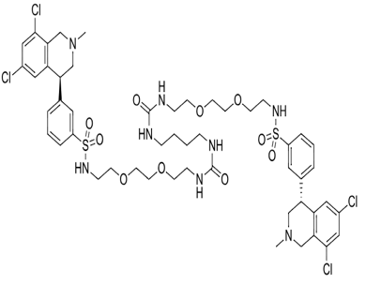 | -5.819 | -65.88 | LYS545, ARG555, CYS622, ASP623, ASP760, ASP761, SER814
Isavuconazonium | 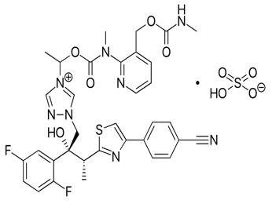 | -5.781 | -54.89 | ASP618, CYS622, ASP761, LYS798, GLU811
Elagolix |  | -5.613 | -71.4 | LYS545, ARG553, ARG555, ASP618, TYR619, LYS621, CYS622, ASP623, PHE694, ASP760
Alatrofloxacin | 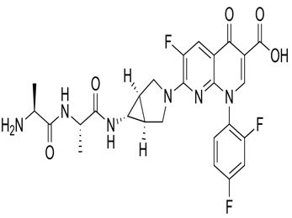 | -5.521 | -48.68 | LYS545, ARG555, THR556, TRP617, ASP618, CYS622, ASP623, ASP624, ASP760, ASP761, ALA762, GLU811
Valrubicin | 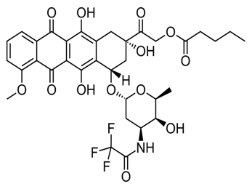 | -5.237 | -50.19 | LYS545, ARG555, THR556, ASP618, CYS622, ASP623, ASP624, SER682, SER759, ASP760

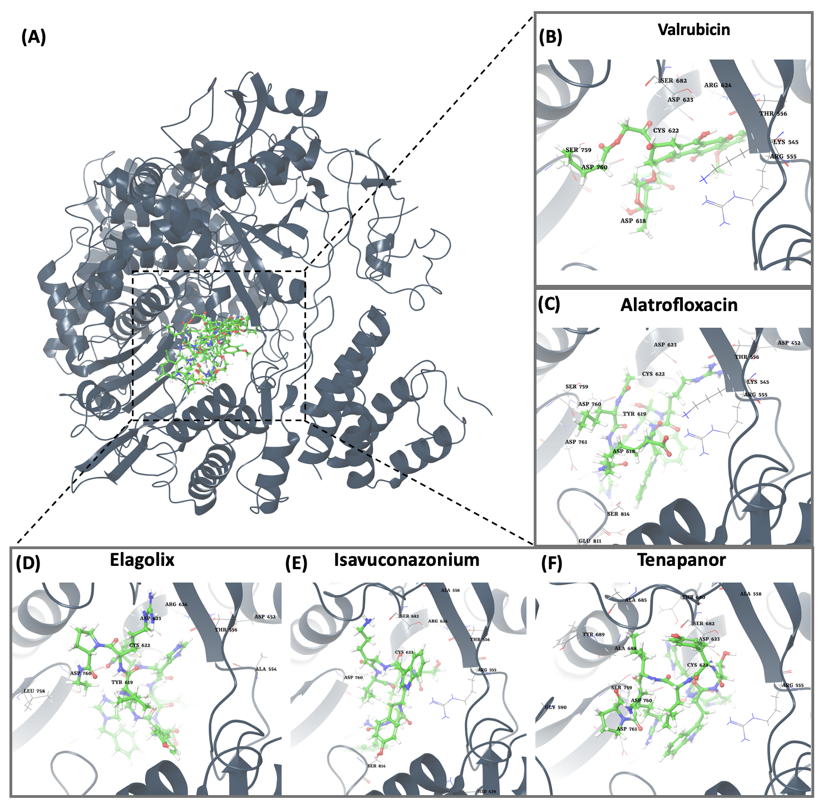
Figure1. (A) The orientation of top-scored small molecules in the binding pocket of the RdRp protein during a nucleophilic substitution reaction, including (B) valrubicin, (C) alatrofloxacin, (D) elagolix, (E) isavuconazonium, and (F) tenapanor.
Michael Addition Reaction Uncover Promising Leads for RNA Virus Polymerase Inhibition RdRp.
Table2. MM-GBSA scores and interaction residues for michael addition reaction’s top molecules and RdRp protein.
Michael Addition Reaction
Compound | 2D Structure | Docking  (kcal/mole) | MM-GBSA  (kcal/mole) | Interaction residues
Capreomycin | 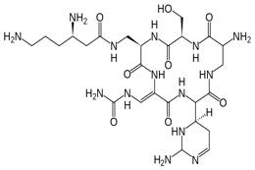 | -7.121 | -74.84 | LYS551, ARG555, ASP618, AYS622, ASP623, SER681, ASN691, SER759, ASP760, ASP761, GLU811, SER814
Ceftolozane | 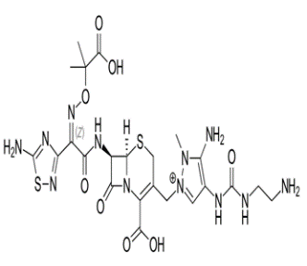 | -6.558 | -86.6 | LYS551, ARG553, ARG555, TRP617, ASP618, TYR619, LYS621, CYS622, ASP760, ASP761, ALA762
Ceftobioprole | 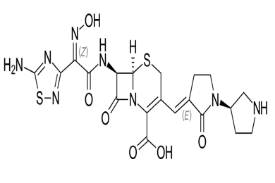 | -6.296 | -78.01 | ASP452, LYS545, ARG553, ARG555, THR556, TRP617, ASP618, TYR619, CYS622, ASP623, ARG624, ASP761

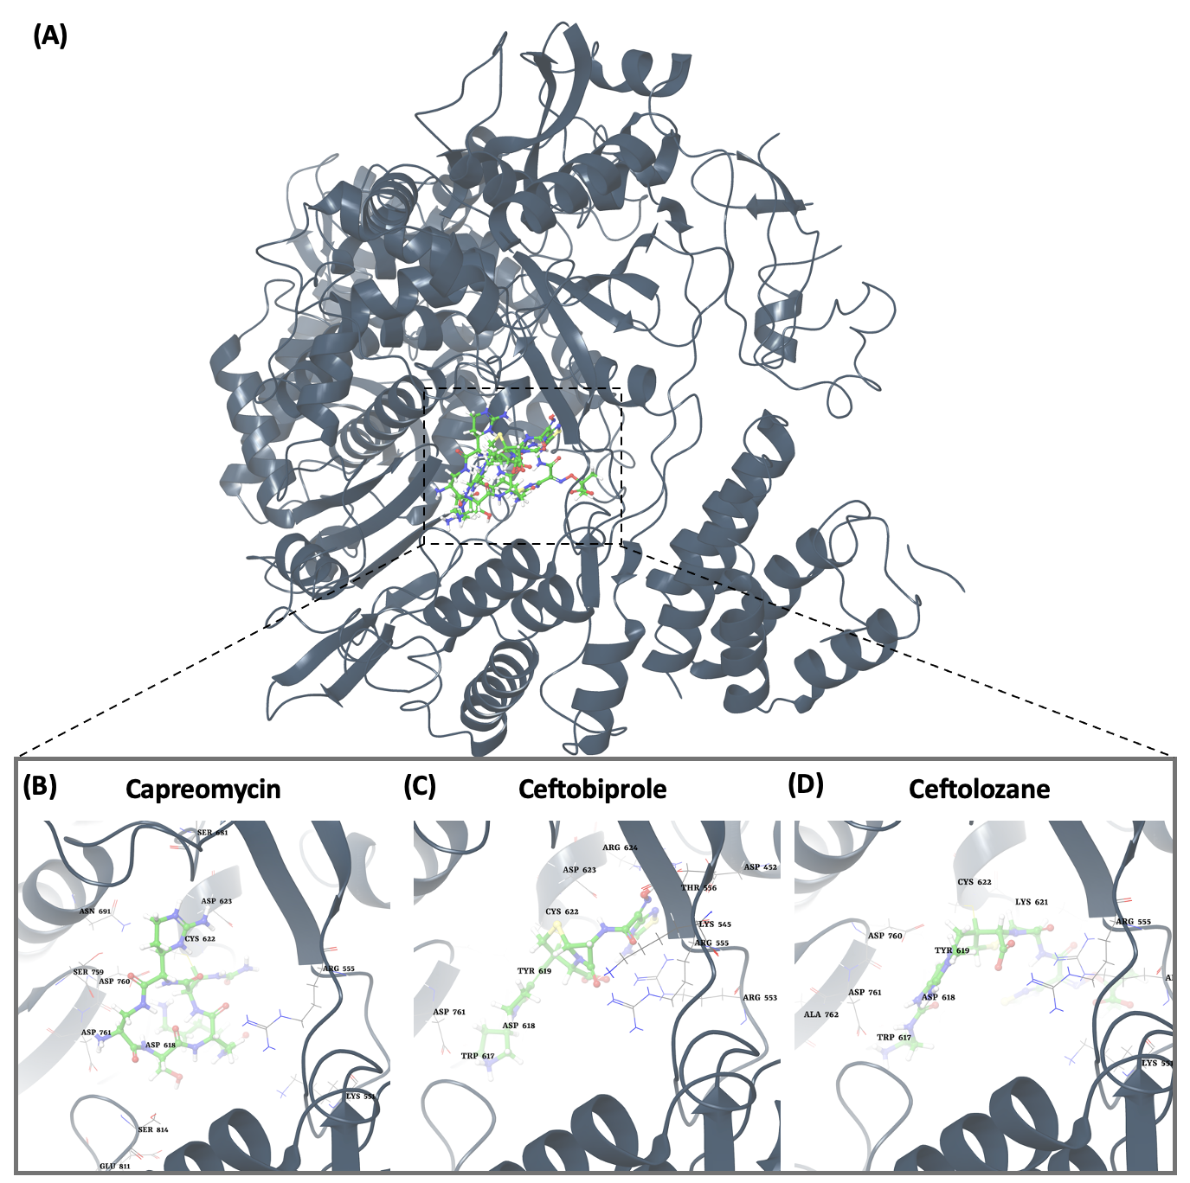
Figure 2. (A) The orientation of top-scored small molecules in the binding pocket of the RdRp protein during a michael addition reaction, including (B) capreomycin, (C) ceftobioprole, and (D) ceftolozane.

Computational Covalent Docking Analysis Explores Nuctriple Binding of Potential Mpro Protein Inhibitors.
Table 3: MM-GBSA scores and interaction residues for nuctriple reaction’s top molecules and Mpro protein.
Nuctriple Reaction
Compound | 2D Structure | Docking  (kcal/mole) | MM-GBSA  (kcal/mole) | Interaction residues
Ozanimod | 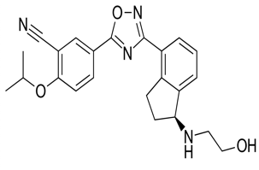 | -4.603 | -58.4 | A:HIS41, A:TYR118, A:ASN119, A:CYS145, A:HIS164
Darolutamide | 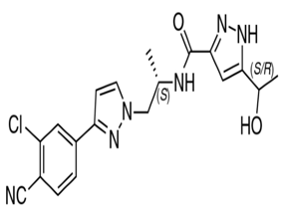 | -3.292 | -57.99 | THR24, THR26, GLY143, CYS145
Selpercatinib | 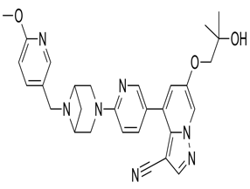 | -2.173 | -57.46 | A:HIS41, A:GLY143, A:CYS145, A:GLU166
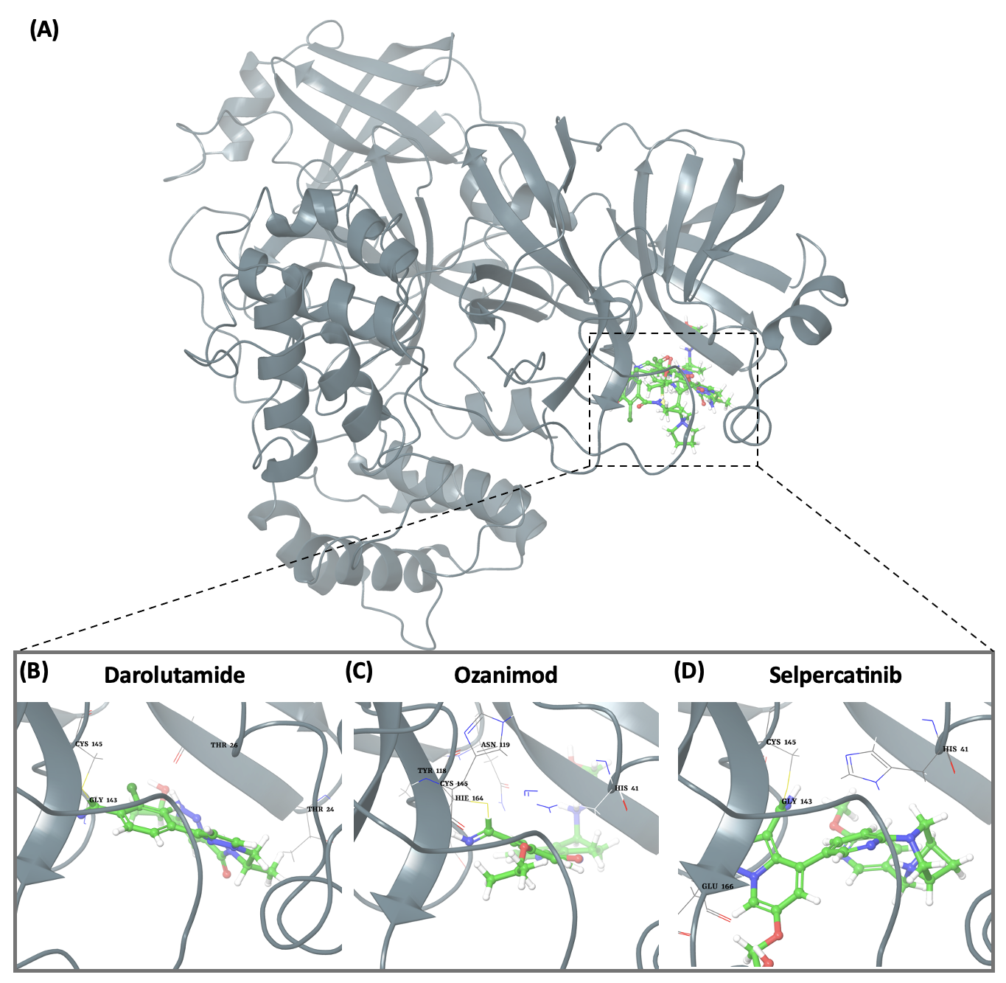
Figure3. (A) The orientation of top-scored small molecules in the binding pocket of the Mpro protein during a nuctriple reaction, including (B) darolutamide, (C) ozanimod, and (D) selpercatinib.

In-Silico Analysis Highlights the Epoxy Reaction as a Pivotal Interaction for Potential Ace2 Inhibitors.

Table 4. MM-GBSA scores and interaction residues for epoxy reaction’s top molecules and Ace2 protein.
Epoxy Reaction
Compound | 2D Structure | Docking  (kcal/mole) | MM-GBSA  (kcal/mole) | Interaction residues
Mupirocin | 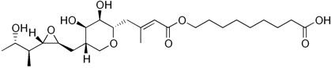 | -4.792 | -125.375 | A:GLU35, A:ASP38, A:GLN42, A:ASN49, B:SER494, B:ARG498
Methscopolamine bromide | 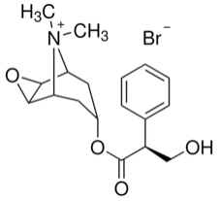 | -3.060 | -156.138 | A:GLU35, B:LYS493, B:SER494
Methscopolamine | 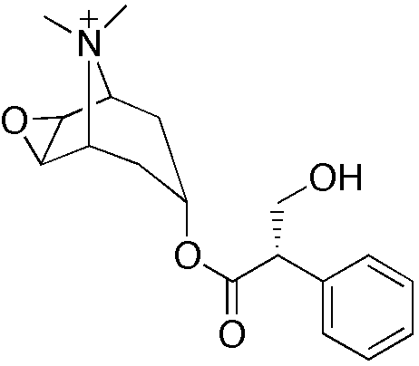 | -2.931 | -112.833 | A:GLU35, B:TYR449

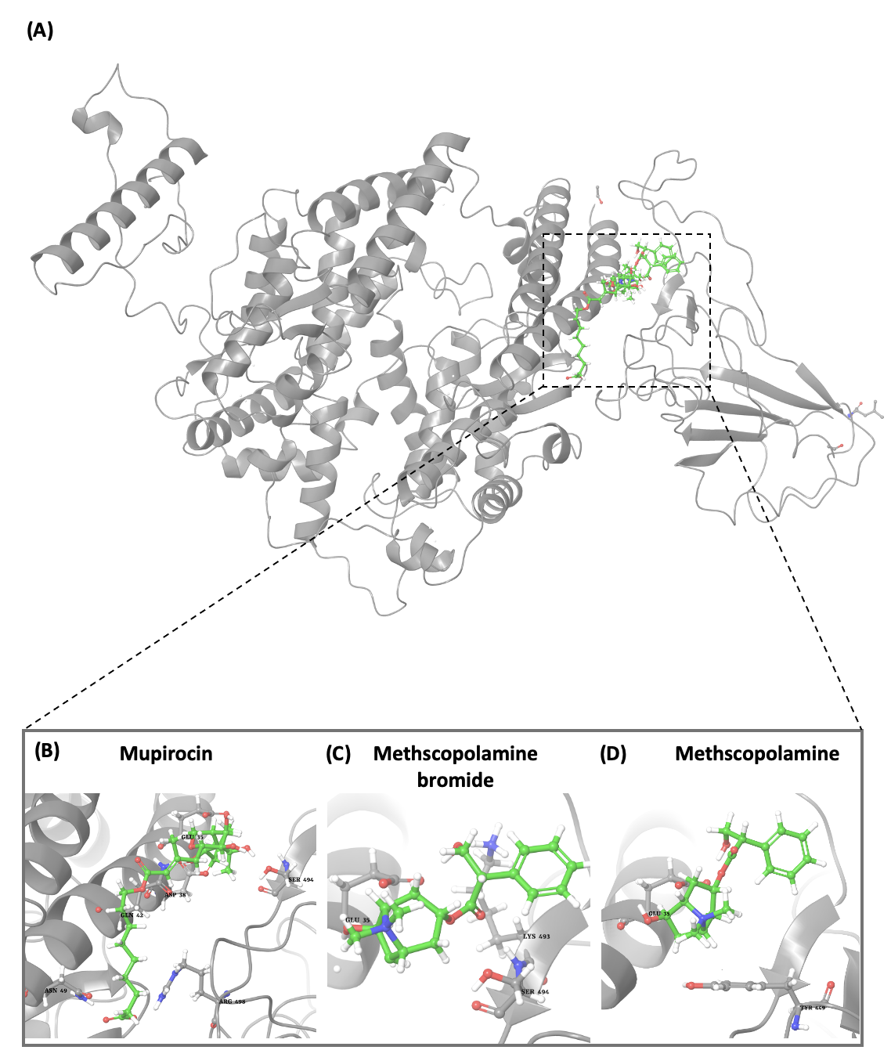
Figure4. (A) The orientation of top-scored small molecules in the binding pocket of the Ace2 protein during epoxy reaction, including (B) Mupirocin, (C) Methscopolamine bromide, and (D) Methscopolamine.

