Supporting Information for

Comprehensive Study of Imidazole-Based Hydrazones: From Design, Synthesis, and Characterization to In Vitro and In Silico Antiproliferative Activity Analysis

Ömer DİLEK

Isparta University of Applied Sciences, Central Research Laboratory Application and Research Center, 32200, Isparta, Türkiye

E-mail: omerdilek@isparta.edu.tr

Table of Contents
Page(s) | Content
S1–S2 | Table of Contents
S3–S10 | NMR Spectra
S3 | ¹H NMR Spectrum of 6 (700 MHz, DMSO-d₆)
S3 | ¹³C{¹H} NMR Spectrum of 6 (APT, 176 MHz, DMSO-d₆)
S4 | ¹H NMR Spectrum of 7a (400 MHz, DMSO-d₆)
S4-S5 | ¹³C{¹H} NMR Spectrum of 7a (APT, 101 MHz, DMSO-d₆)
S6 | ¹H NMR Spectrum of 7b (400 MHz, DMSO-d₆)
S6-S7 | ¹³C{¹H} NMR Spectrum of 7b (APT, 101 MHz, DMSO-d₆)
S7 | ¹H NMR Spectrum of 7c (400 MHz, DMSO-d₆)
S8 | ¹³C{¹H} NMR Spectrum of 7c (APT, 101 MHz, DMSO-d₆)
S9 | ¹H NMR Spectrum of 7d (400 MHz, DMSO-d₆)
S9-S10 | ¹³C{¹H} NMR Spectrum of 7d (APT, 101 MHz, DMSO-d₆)
S11-20 | Mass Spectra
S11 | Mass Spectrum of 6 (Positive Mode)
S12 | Mass Spectrum of 6 (Negative Mode)
S13 | Mass Spectrum of 7a (Positive Mode)
S14 | Mass Spectrum of 7a (Negative Mode)
S15 | Mass Spectrum of 7b (Positive Mode)
S16 | Mass Spectrum of 7b (Negative Mode)
S17 | Mass Spectrum of 7c (Positive Mode)
S18 | Mass Spectrum of 7c (Negative Mode)
S19 | Mass Spectrum of 7d (Positive Mode)
S20-22 | FTIR Spectra
S20 | FTIR Spectra of 6
S20 | FTIR Spectra of 7a
S21 | FTIR Spectra of 7b
S21 | FTIR Spectra of 7c
S22 | FTIR Spectra of 7d

NMR Spectra
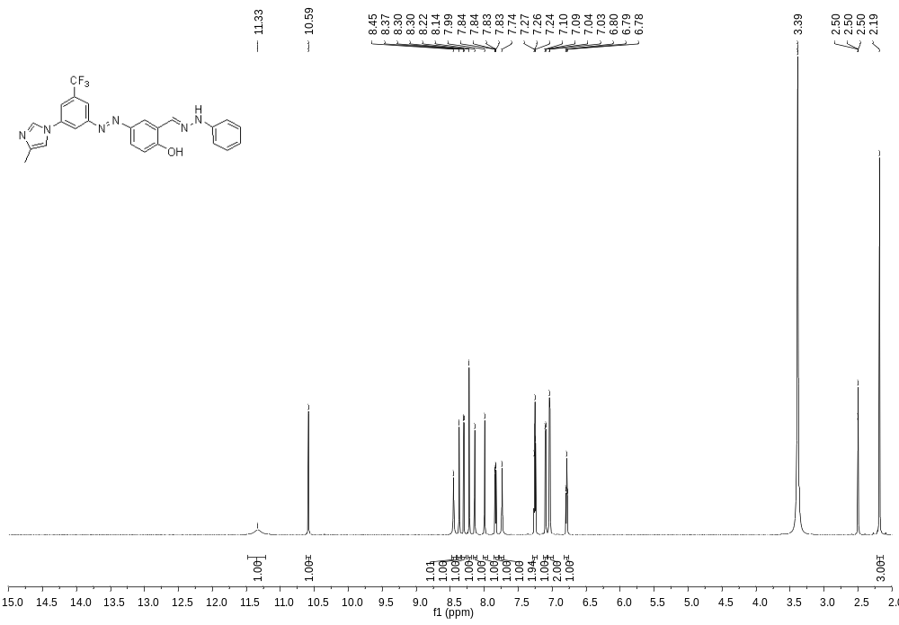
¹H-NMR Spectrum of 6 (700 MHz, DMSO-d₆)

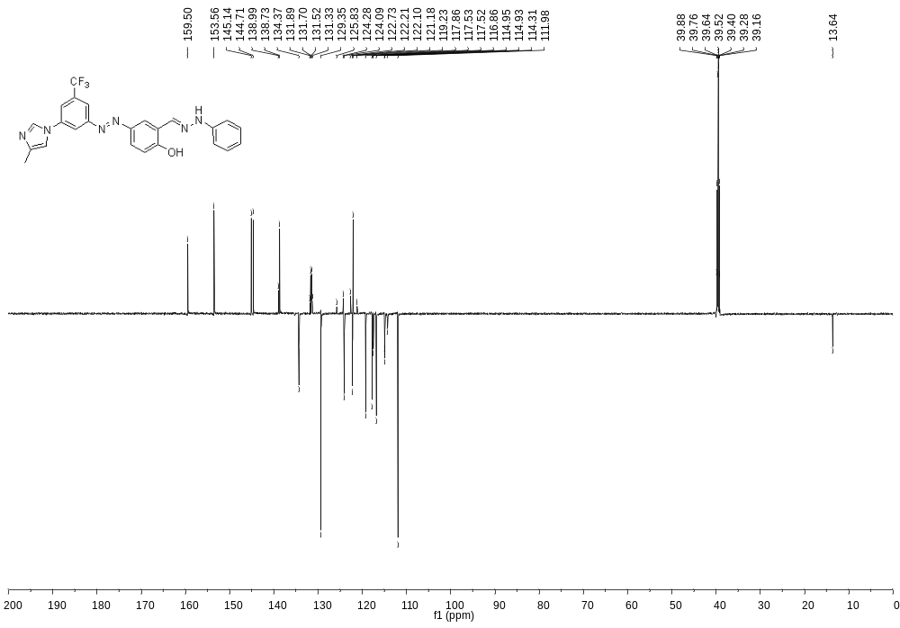
¹³C{¹H} NMR Spectrum of 6 (APT, 176 Mhz, DMSO-d₆)
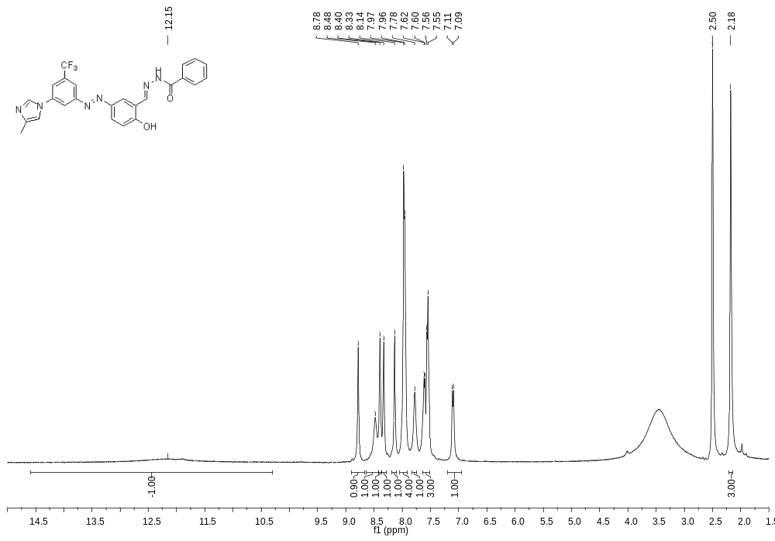
¹H-NMR Spectrum of 7a (400 MHz, DMSO-d₆)

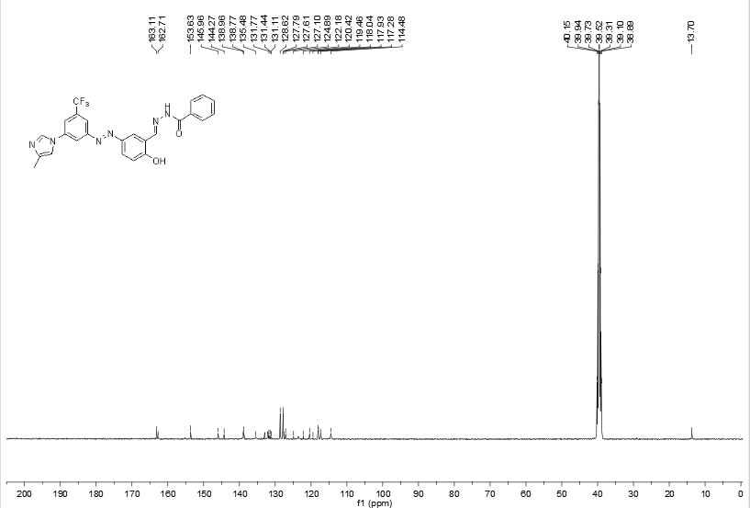
¹³C{¹H} NMR Spectrum of 7a (APT, 101 MHz, DMSO-d₆)

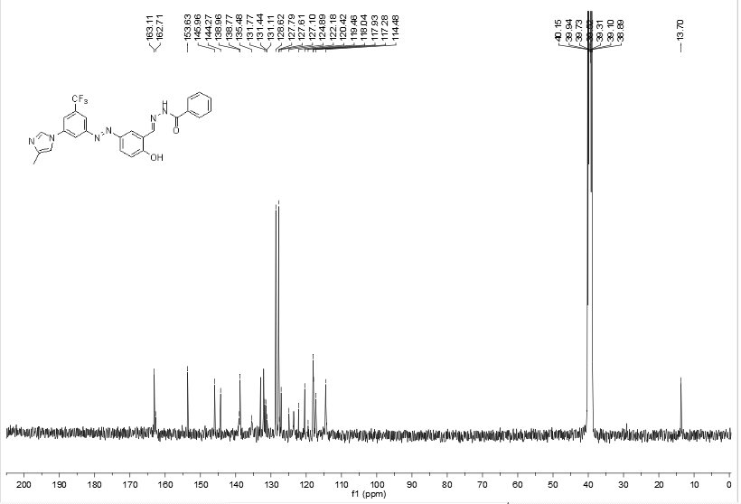
¹³C{¹H} NMR Spectrum of 7a (APT, 101 MHz, DMSO-d₆)

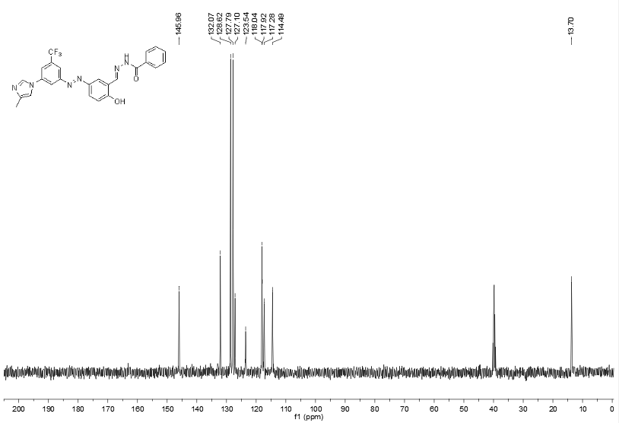
¹³C{¹H}-DEPT NMR Spectrum of 7a (APT, 101 MHz, DMSO-d₆)

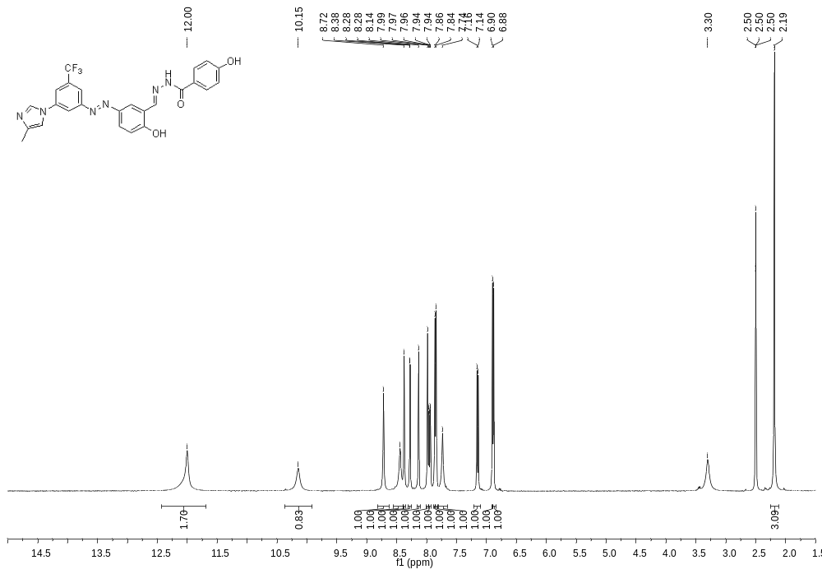
¹H-NMR Spectrum of 7b (400 MHz, DMSO-d₆)

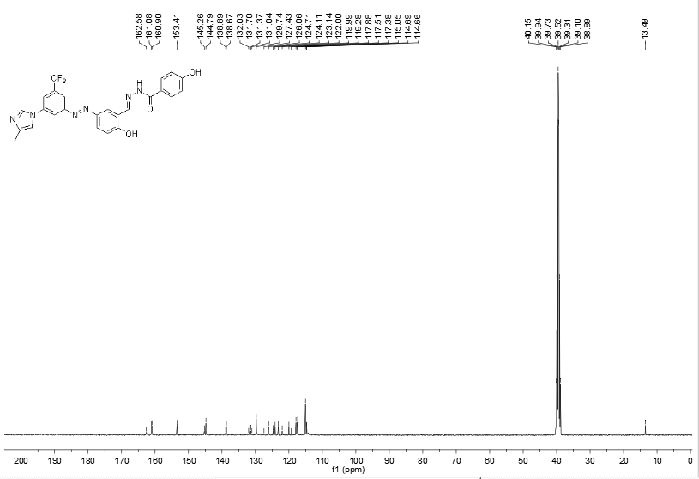
¹³C{¹H} NMR Spectrum of 7b (APT, 101 MHz, DMSO-d₆)

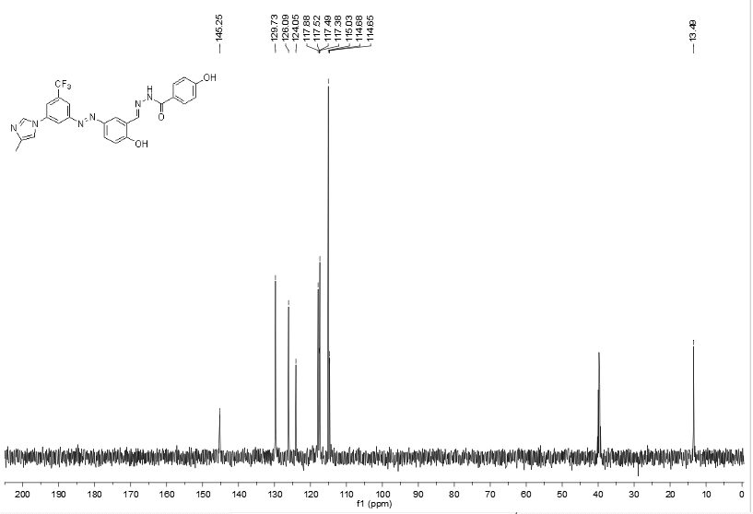
¹³C{¹H}-DEPT NMR Spectrum of 7b (APT, 101 MHz, DMSO-d₆)

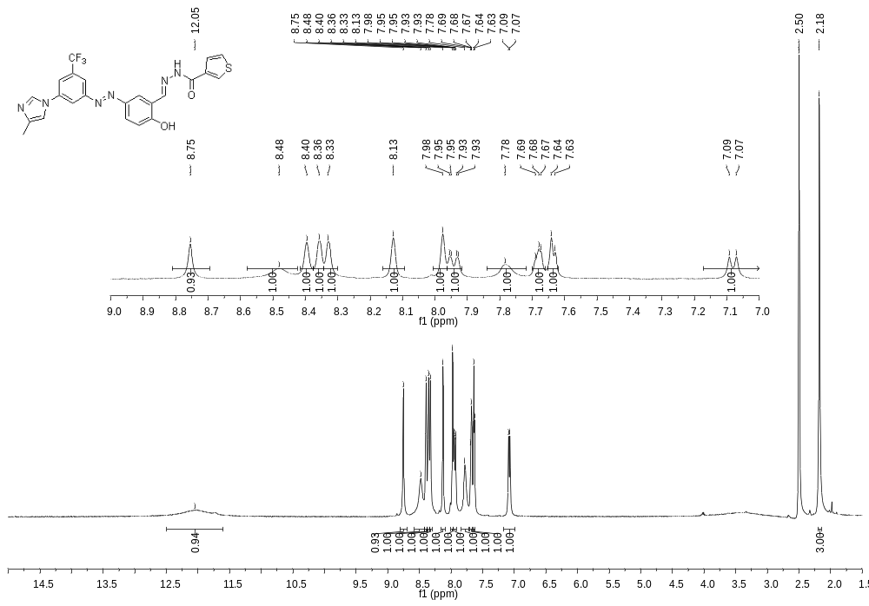
¹H-NMR Spectrum of 7c (400 MHz, DMSO-d₆)
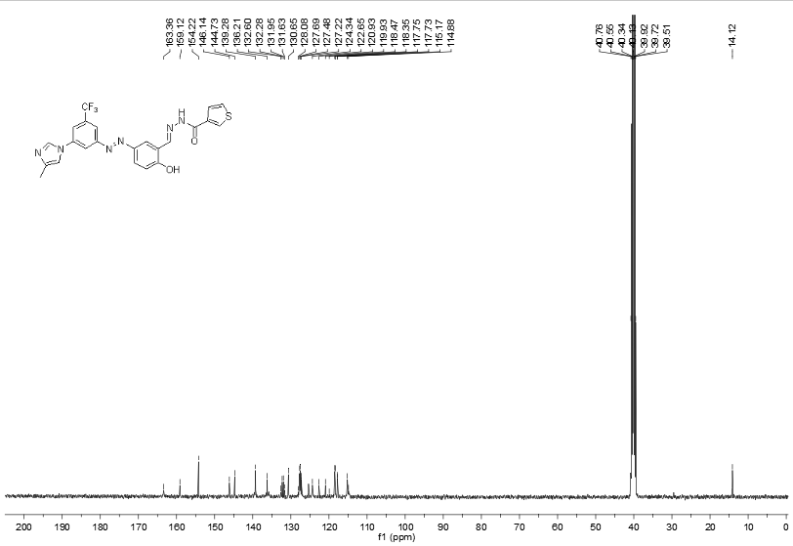
¹³C{¹H} NMR Spectrum of 7c (APT, 101 MHz, DMSO-d₆)

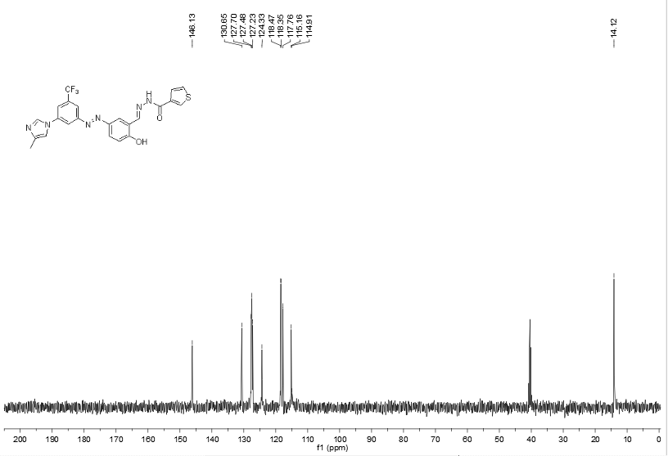
¹³C{¹H}-DEPT NMR Spectrum of 7c (APT, 101 MHz, DMSO-d₆)

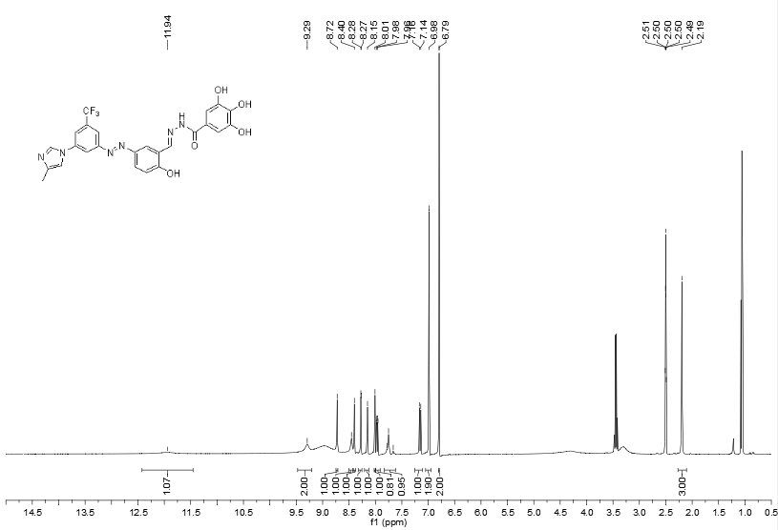
Ethanol solvent residue

¹H-NMR Spectrum of 7d (400 MHz, DMSO-d₆)

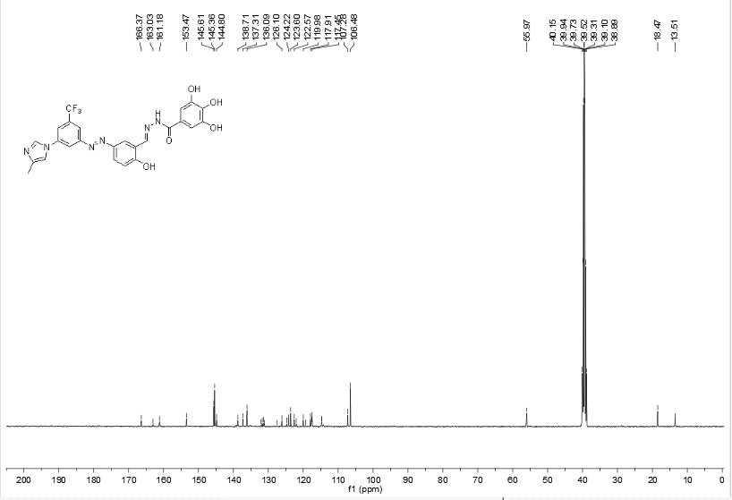
Ethanol solvent residue
¹³C{¹H} NMR Spectrum of 7d (APT, 101 MHz, DMSO-d₆)

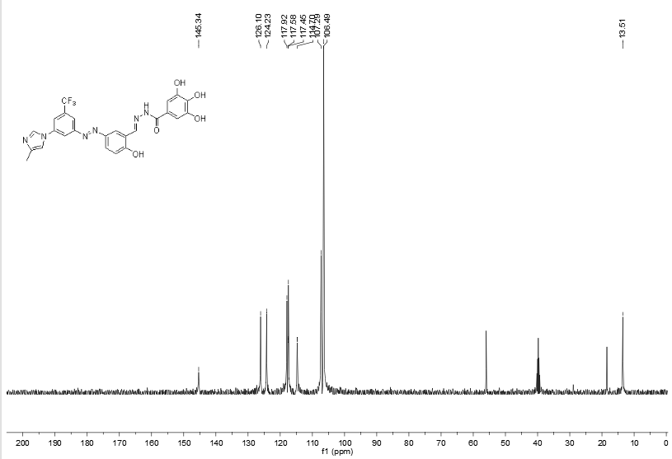
Ethanol solvent residue

¹³C{¹H}-DEPT NMR Spectrum of 7d (APT, 101 MHz, DMSO-d₆)

Mass Spectra

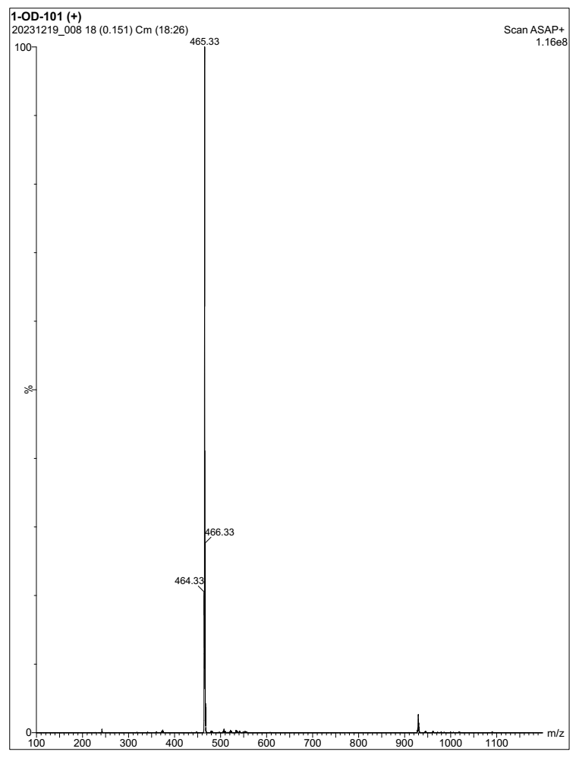
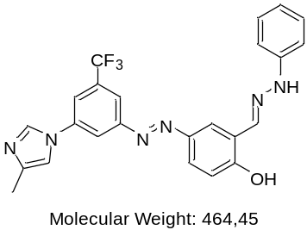
Mass Spectrum of compound 6 (Positive Mode)

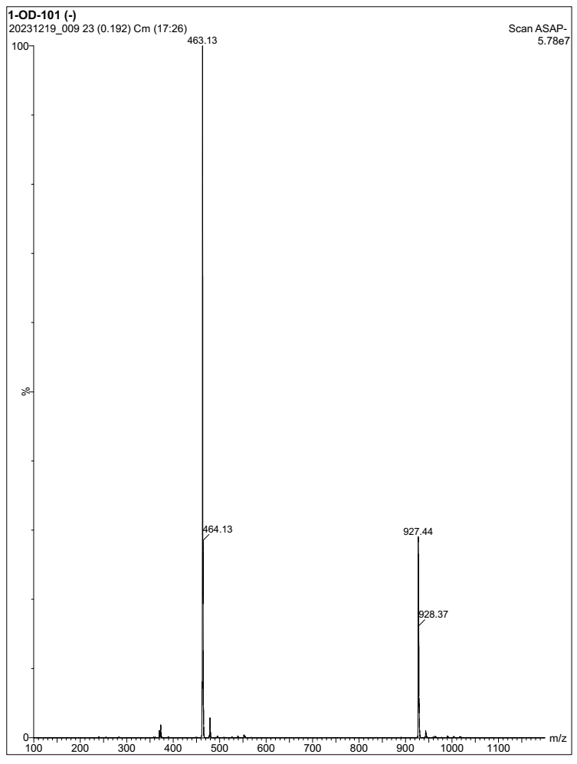
Mass Spectrum of compound 6 (Negative Mode)

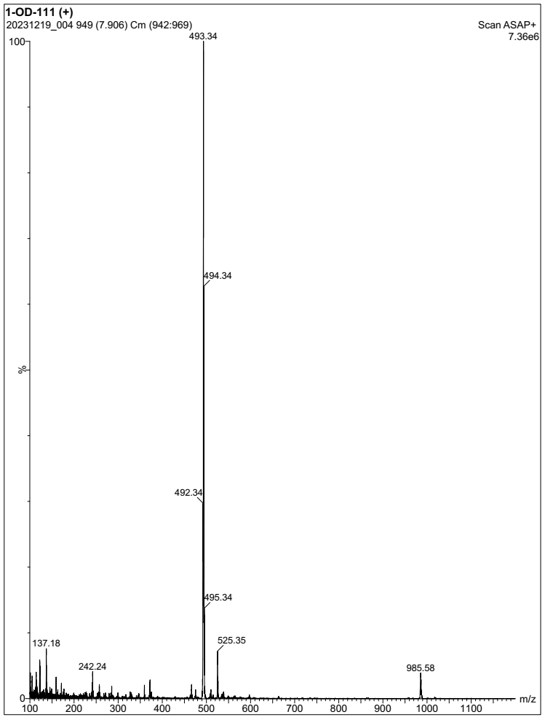
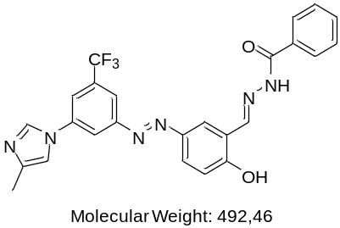
Mass Spectrum of compound 7a (Positive Mode)

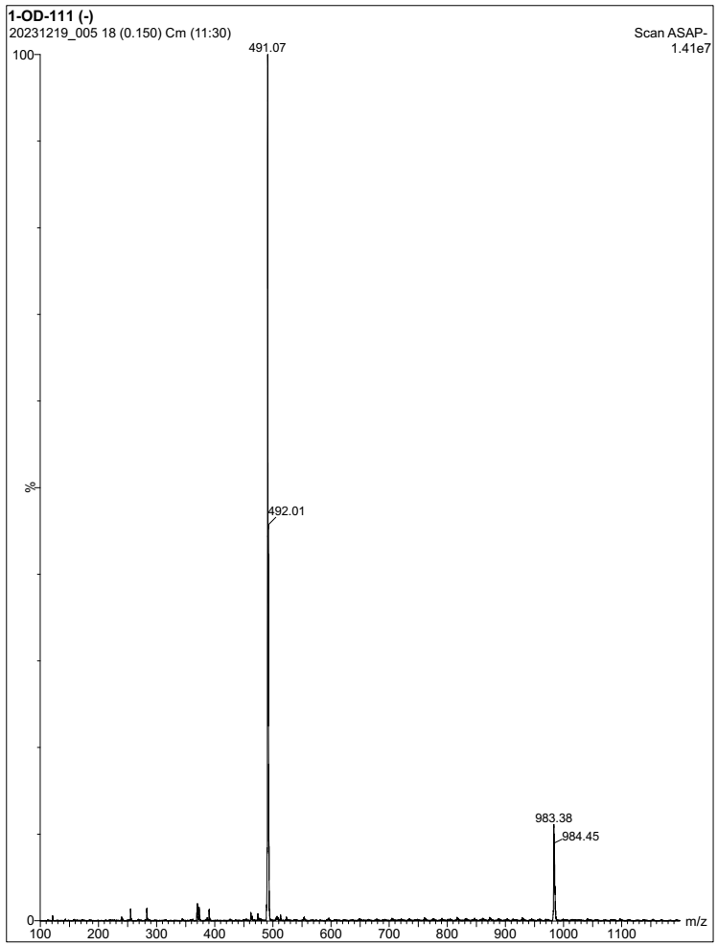
Mass Spectrum of compound 7a (Negative Mode)
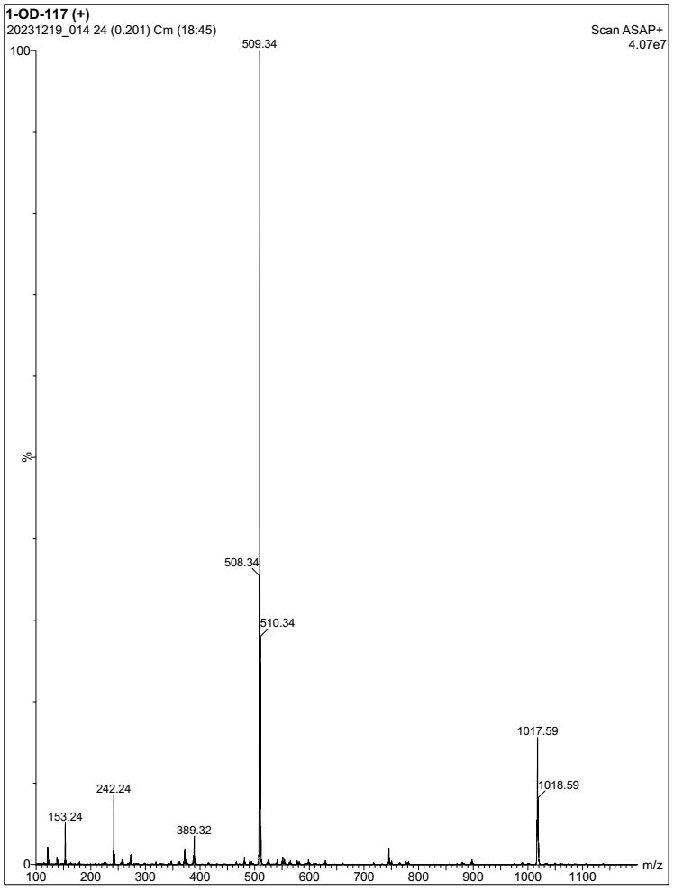
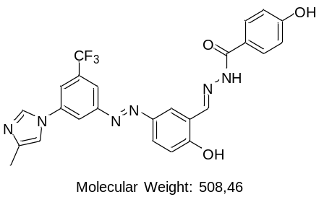
Mass Spectrum of compound 7b (Positive Mode)
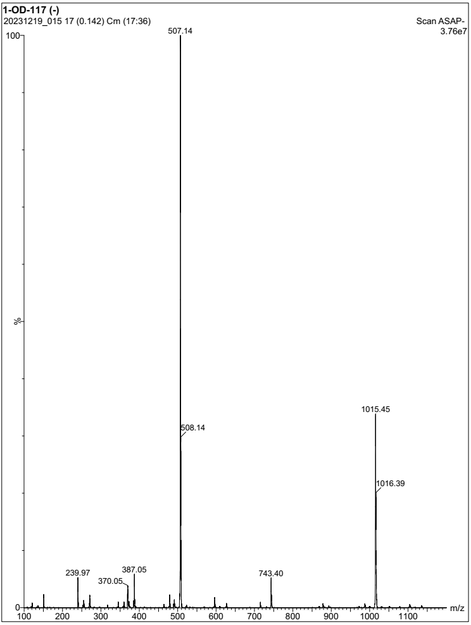
Mass Spectrum of compound 7b (Negative Mode)

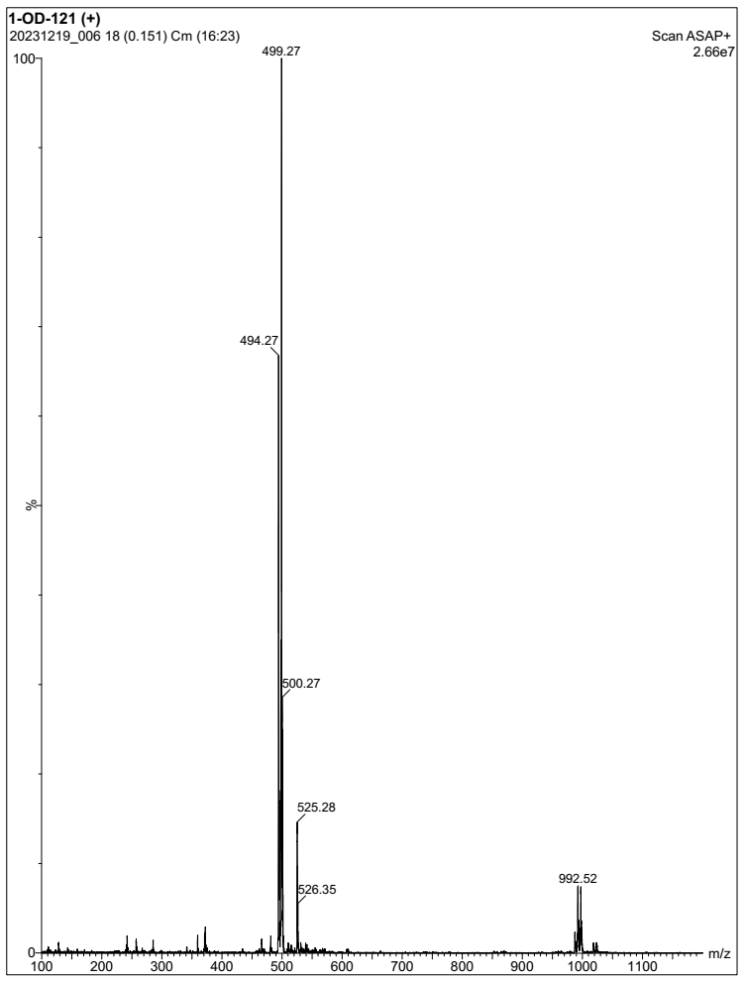
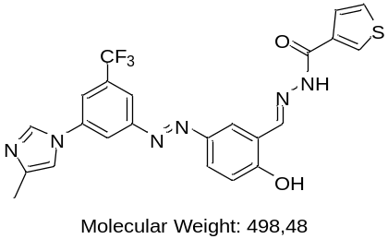
Mass Spectrum of compound 7c (Positive Mode)

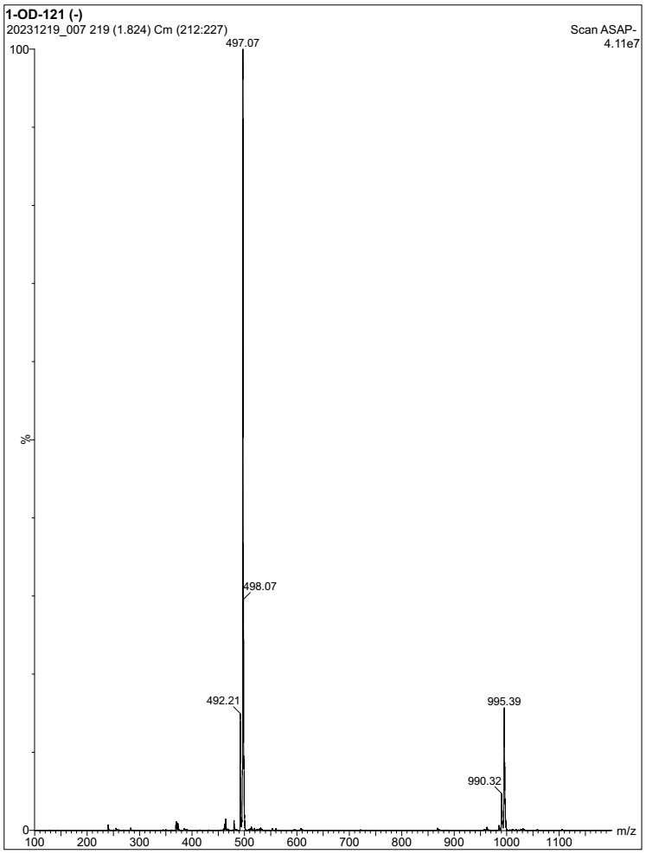
Mass Spectrum of compound 7c (Negative Mode)

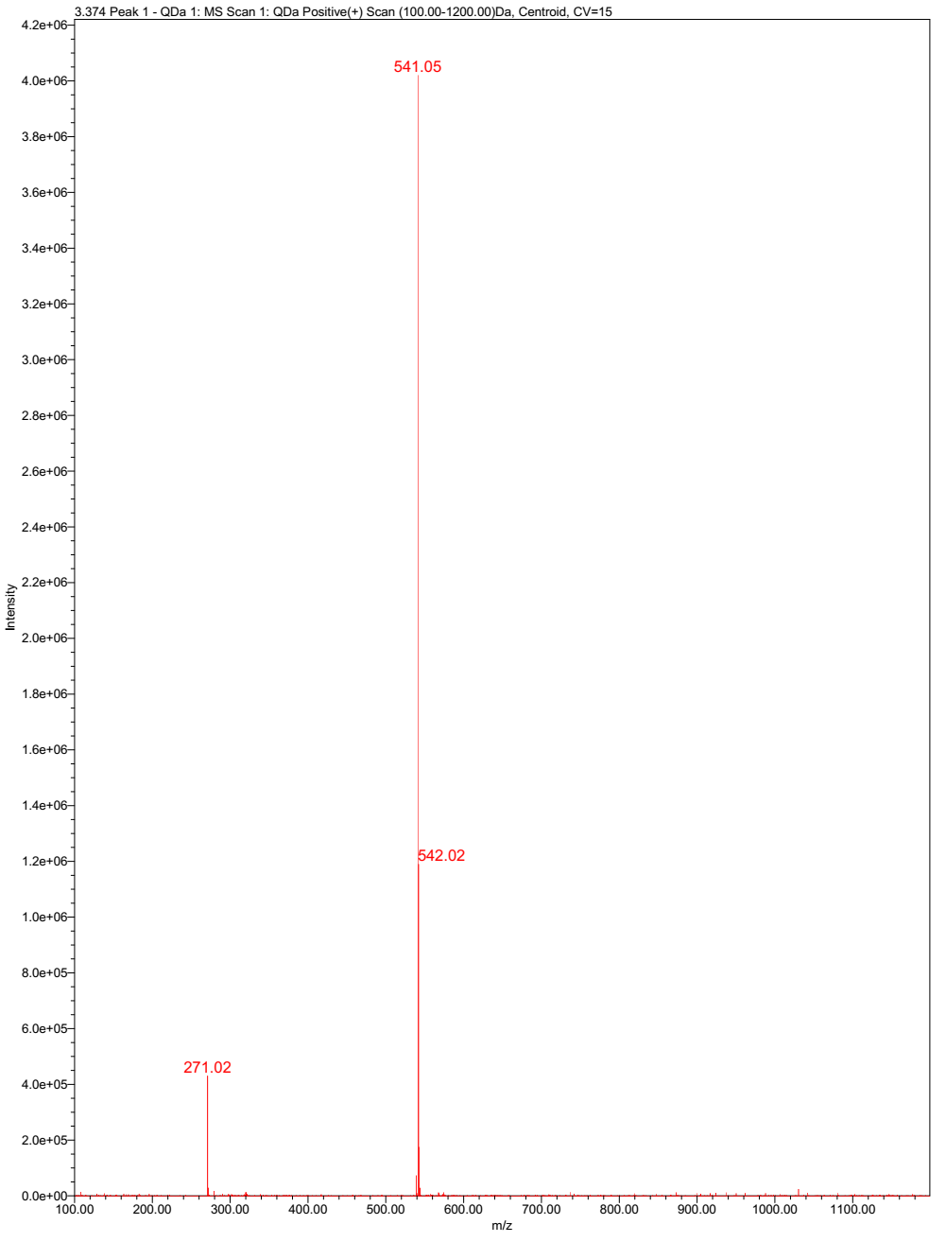
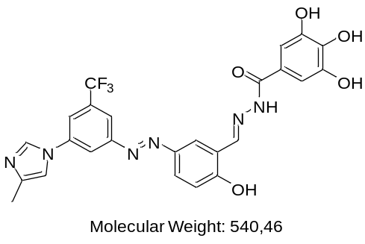
Mass Spectrum of compound 7d (Positive Mode)

FTIR Spectra
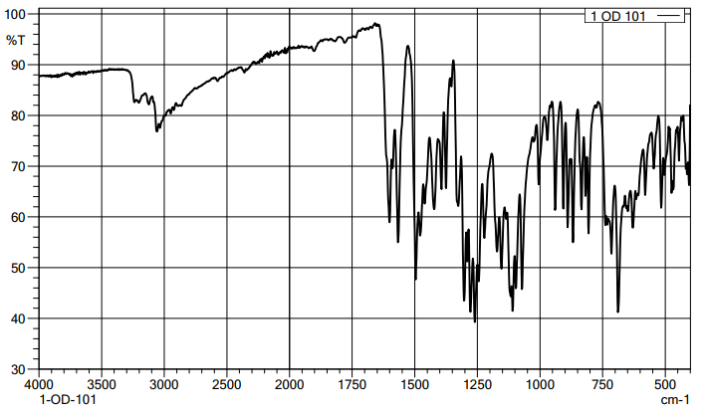
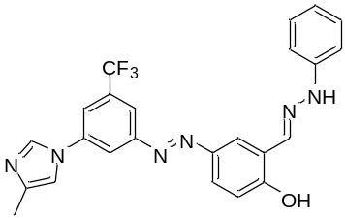
FTIR Spectrum of compound 6

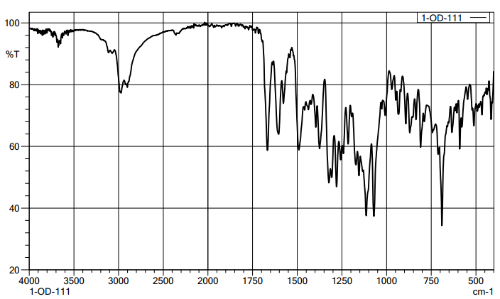
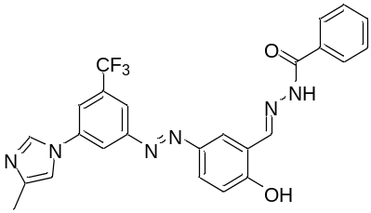
FTIR Spectrum of compound 7a

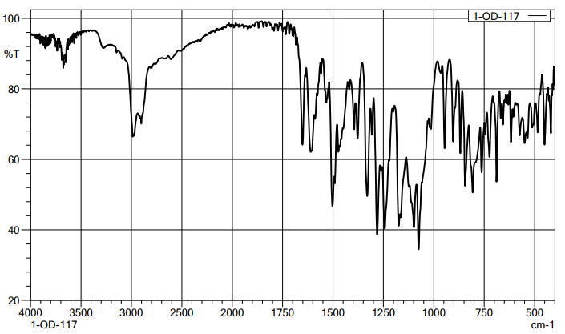
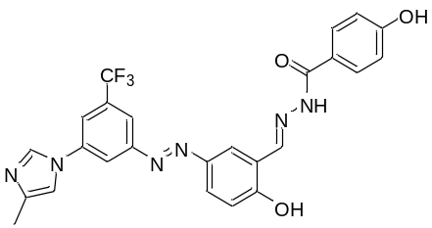
FTIR Spectrum of compound 7b

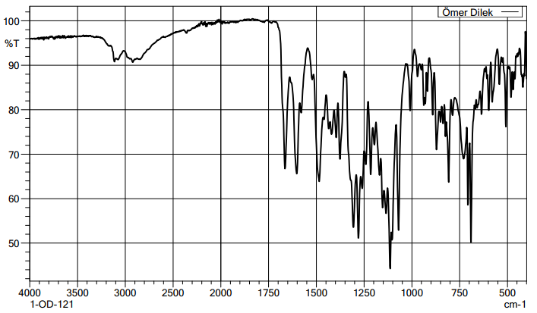
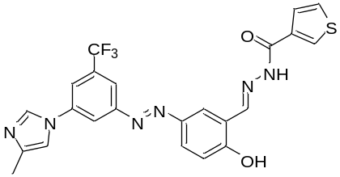
FTIR Spectrum of compound 7c

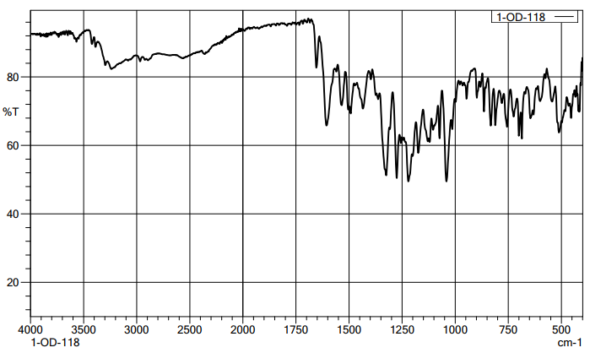
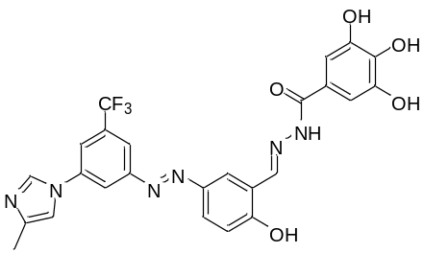
FTIR Spectrum of compound 7d

