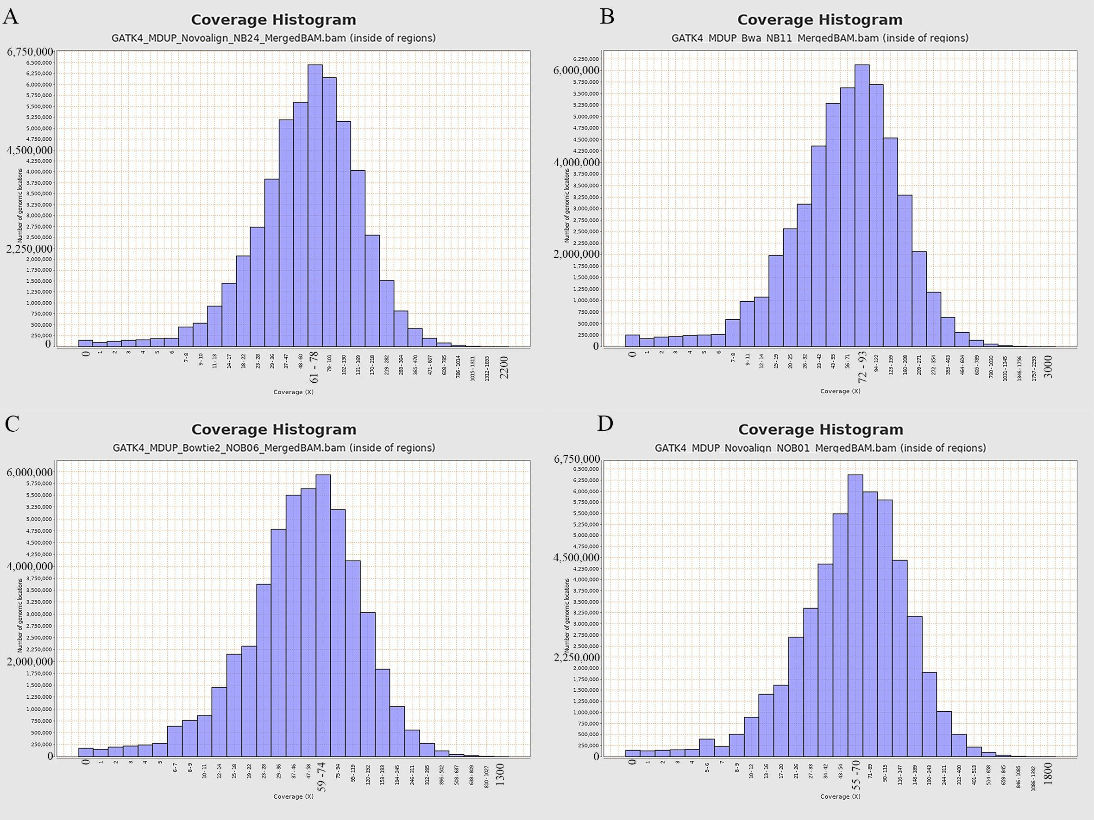
Supplementary Figure 1. Coverage distribution for some samples. (A) 52 million mapped reads inside exome regions, coverage is 87 (B) 54 million mapped reads inside exome regions, coverage is 93 (C) 40 million mapped reads inside exome regions, coverage is 67 (D) 50 million mapped reads inside exome regions, coverage is 83.
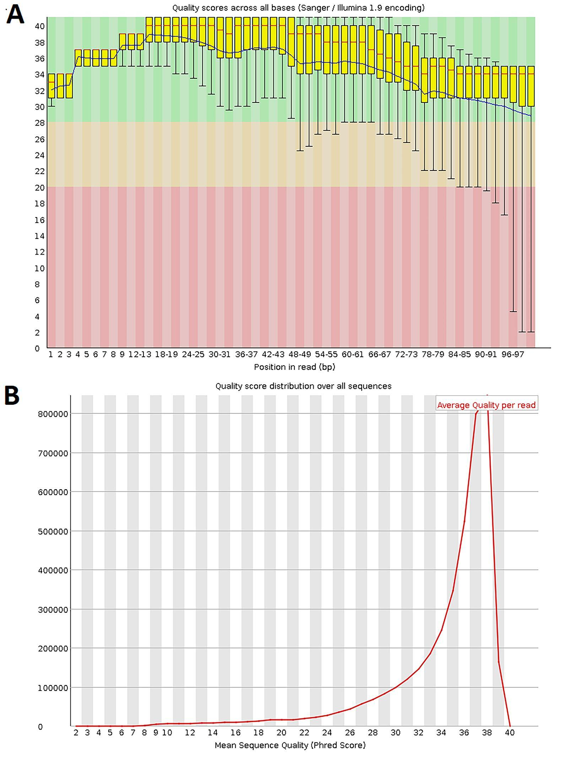
Supplementary Figure 2. Quality distribution of reads. (A) y-axis shows the quality score of reads in each relative base pair at x-axis. Green side of the graph shows the reads are in good quality. (B) shows that how many reads are there in y-axis for each quality score in x-axis. Most reads around mean quality score as seen in figure.
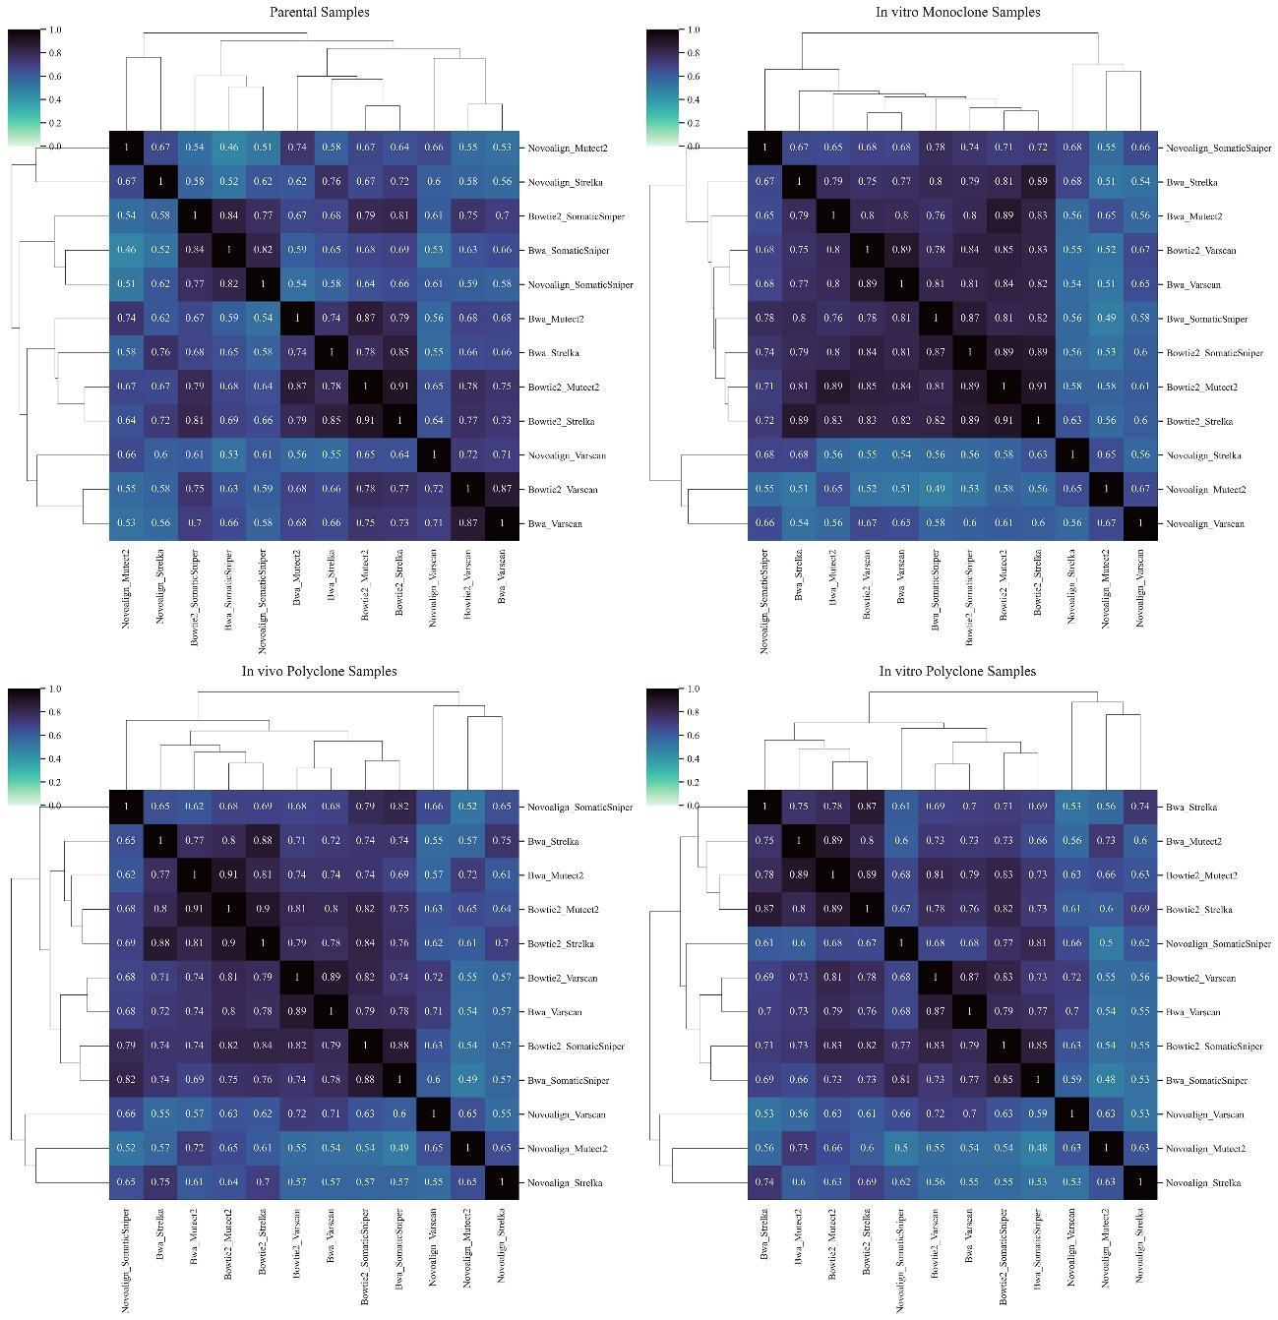
Supplementary Figure 3. Clustered Jaccard similarity matrices for each sample type (top left ‒ parental, top right ‒ in vitro Monoclone, bottom left ‒ in vivo polyclone and bottom right ‒ in vitro polyclone). “Jaccard” similarity values are represented in the cells along with the color scale (dark colors ‒ higher Jaccard similarity and light colors ‒ lower Jaccard similarity among pairs). Dendrograms indicate hierarchical clusters among pipelines. Thus, pipelines with a higher similarity were clustered together.

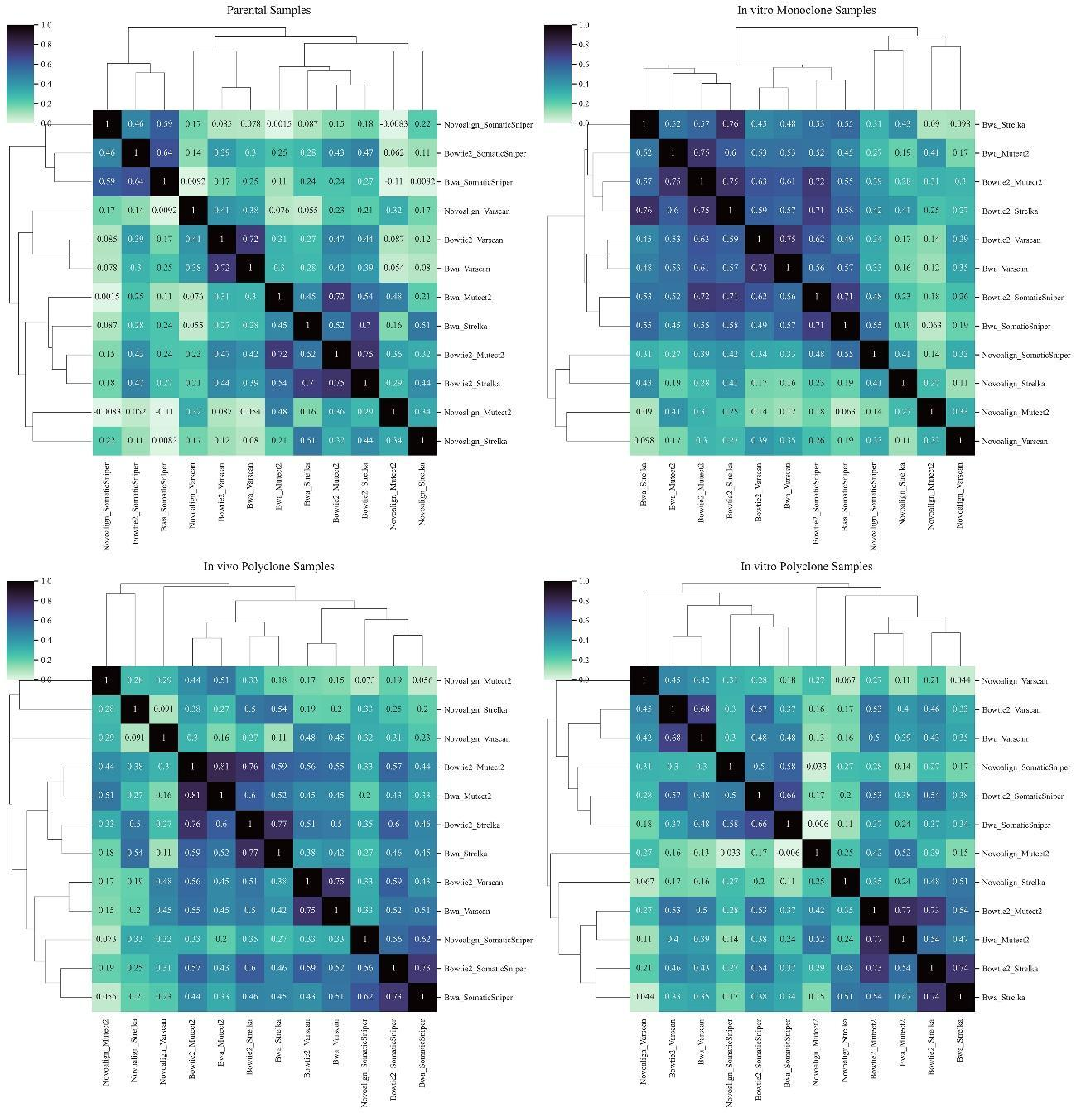
Supplementary Figure 4. Clustered Pearson similarity matricesfor each sample type (top left ‒ parental, top right ‒ in vitro Monoclone, bottom left ‒ in vivo polyclone and bottom right ‒ in vitro polyclone). “Pearson” similarity values are represented in the cells along with the color scale (dark colors ‒ higher Pearson similarity and light colors ‒ bottom left ‒ in vivo polyclone and botDendrograms indicate hierarchical clusters among pipelines. Thus, pipelines with a higher similarity were clustered together.

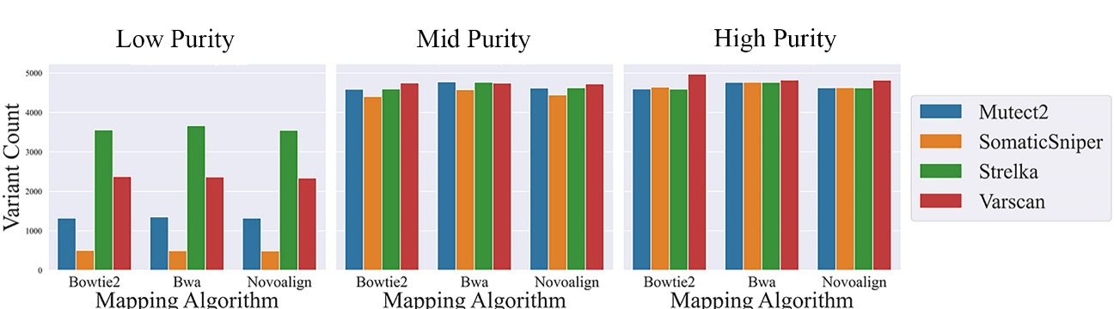
Supplementary Figure 5. Number of total found variants in the simulated dataset. From left to right, High Heterogeneity, Medium Heterogeneity and Low Heterogeneity bar charts are shown colored by variant caller and clustered by aligner preferences.

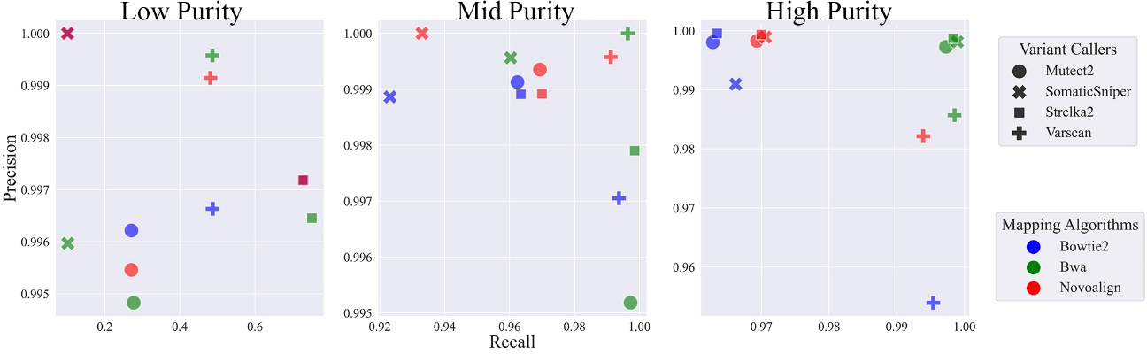
Supplementary Figure 6. Scatter plots for precision-recall scores. Y-axis represents precision and X-axis shows recall. Color and markers are the same with the other scatter plot tables.

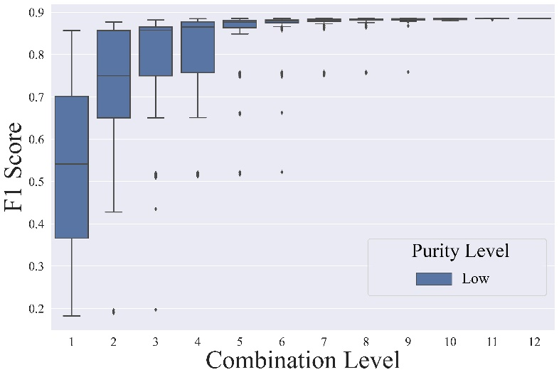
Supplementary Figure 7. Boxplot distribution of the F1 scores depending on the combination of pipelines in the Low Purity Environment. Choosing a single pipeline has a high variance of F1 score depending on the variant caller option.

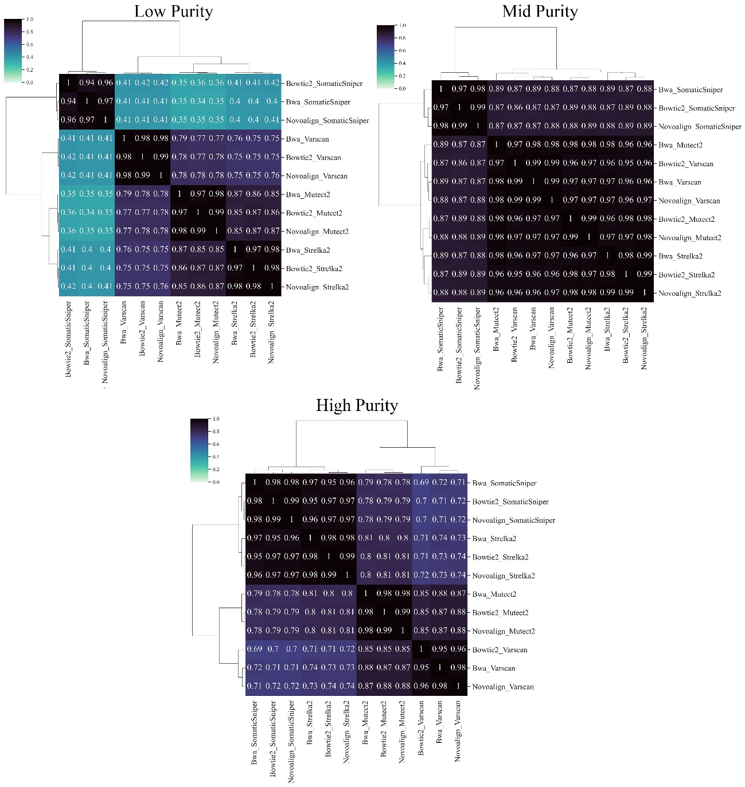
Supplementary Figure 8. Clustered cosine similarity matrices for each purity environment in simulation data.
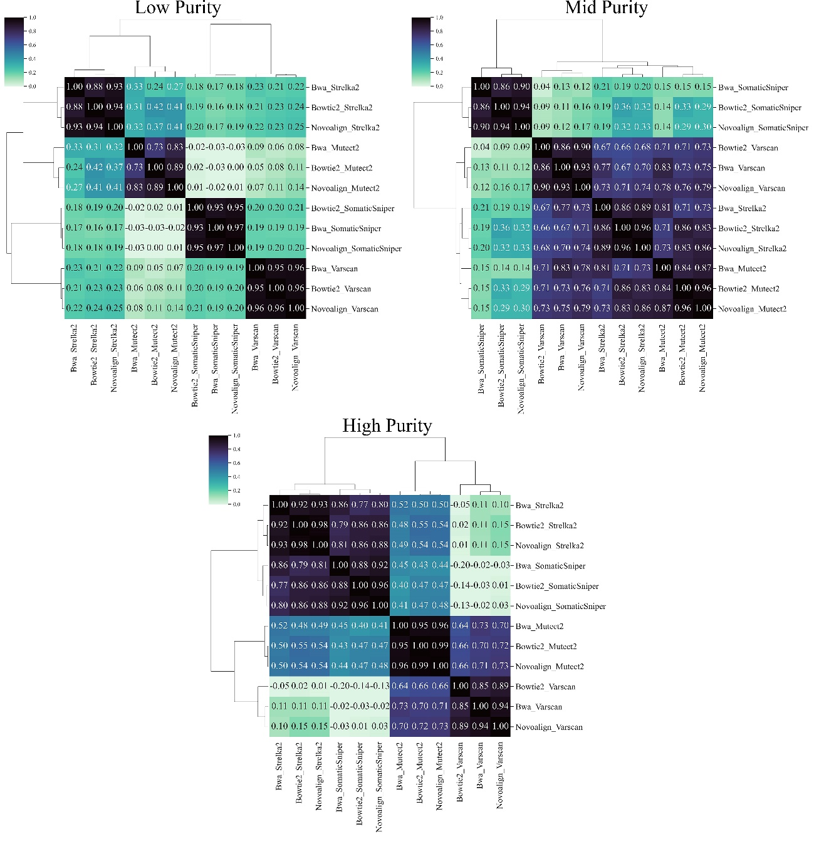
Supplementary Figure 9. Clustered Pearson similarity matrices for each purity environment in simulation data.
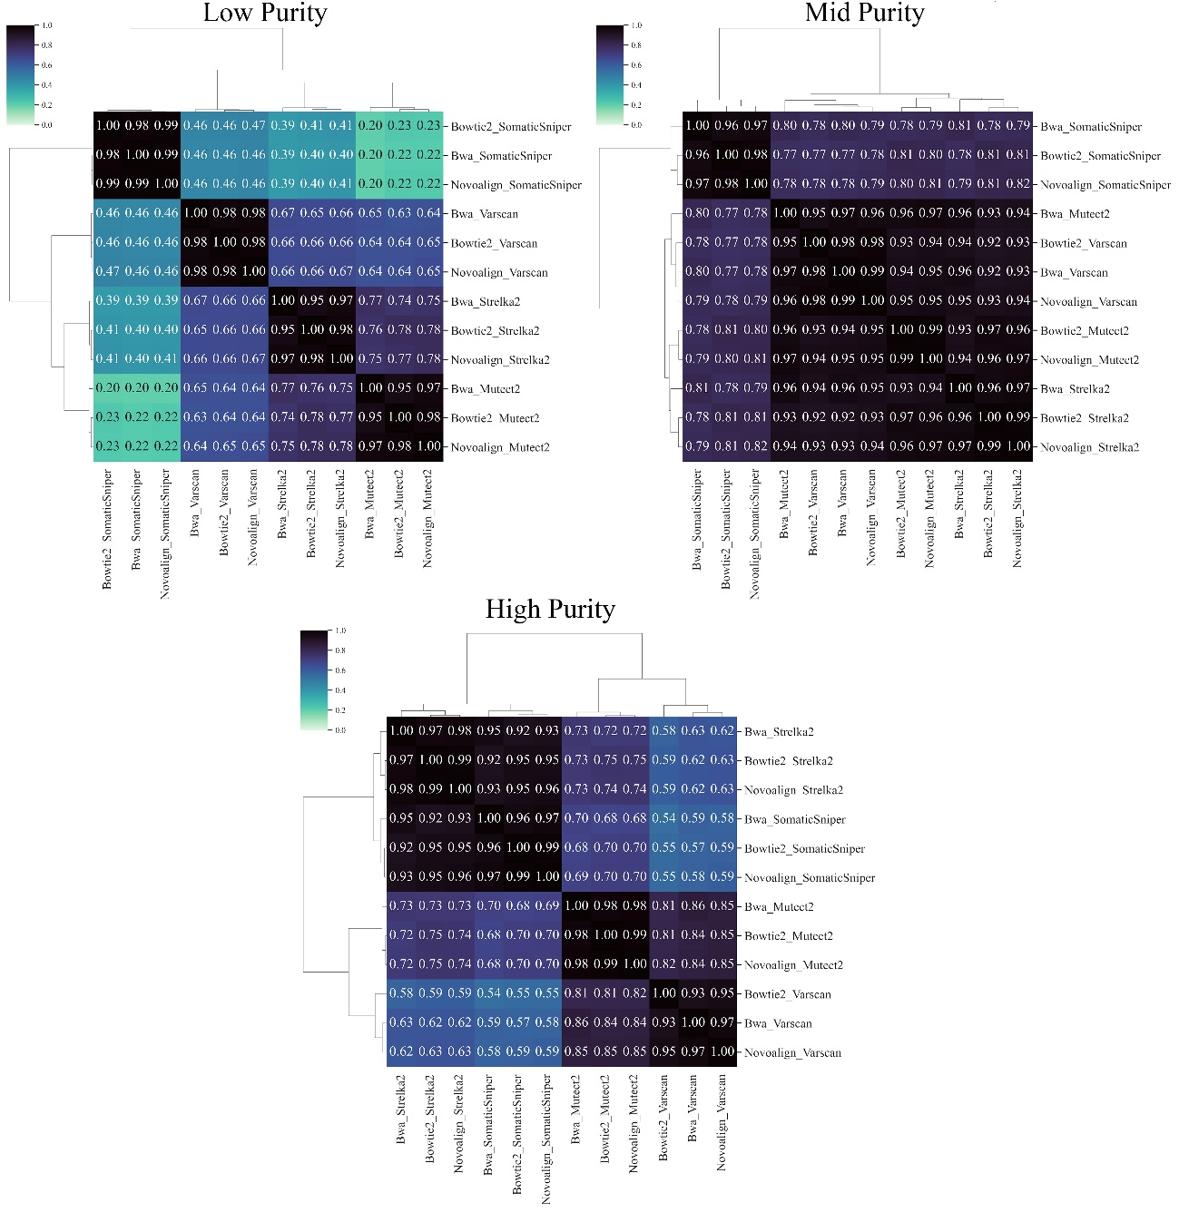
Supplementary Figure 10. Clustered Jaccard similarity matrices for each purity environment in simulation data.

